AWS Lambda:

1. What is AWS Lambda?
It’s a service to run your code without servers — AWS manages the infrastructure for you.

2. Why Use Lambda?
You don’t worry about servers, and it scales automatically with demand.

3. Where is Lambda Used?
For backend APIs, data processing, file handling, automation, and reacting to AWS events.

4. How Does Lambda Work?
You upload code (called a function), AWS runs it when triggered by events (like API calls or file uploads).

5. Supported Languages
Works with Python, JavaScript (Node.js), Java, Go, Ruby, C#, and more.

6. Costing
You pay only for how long your code runs and how many times it executes. Free tier offers 1 million free requests/month.

7. Execution Limits
Each function runs up to 15 minutes max, and uses memory you allocate (128 MB to 10 GB).

8. Integration
Lambda works with many AWS services like S3, DynamoDB, API Gateway, SNS, SQS, CloudWatch, etc.

9. Security
Runs with roles defining what it can access; can be placed inside private networks (VPC).

10. Best Practices
Keep functions simple, use environment variables for configs, handle errors, and monitor with CloudWatch.

API Gateway

1. What is AWS API Gateway?
A fully managed service to create, publish, and manage APIs (REST, HTTP, WebSocket).

2. Why Use API Gateway?
It makes it easy to build and secure APIs without managing servers or infrastructure.

3. Where is API Gateway Used?
For building backend APIs that connect to Lambda, EC2, or other web services.

4. How Does API Gateway Work?
It receives API requests, processes them (authorization, throttling), and routes to backend services.

5. Types of APIs Supported
REST APIs, HTTP APIs (simpler, cheaper), and WebSocket APIs (for real-time apps).

6. Costing
Charged per million API calls and data transferred. HTTP APIs cost less than REST APIs.

7. Security Features
Supports API keys, IAM roles, Cognito user pools, and custom authorizers for access control.

8. Throttling and Quotas
You can limit requests to protect your backend from overload.

9. Monitoring
Integrated with CloudWatch for logging and metrics to track API usage and errors.

10. Best Practices
Use caching to improve performance, enable logging for debugging, and secure APIs with proper authentication.

Short Demo testing task on Lambda and API Gateway.(Accesing lambda through API)
Create a lambda function

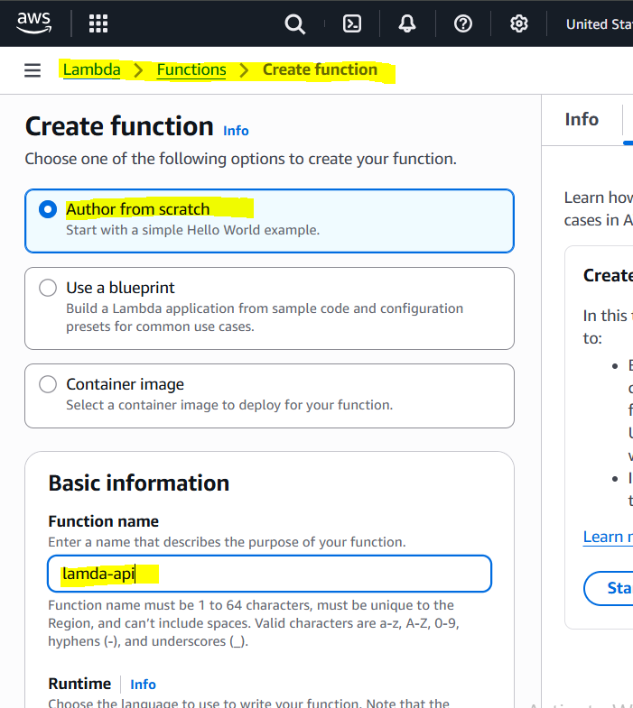

Select any programming language and click on Create function
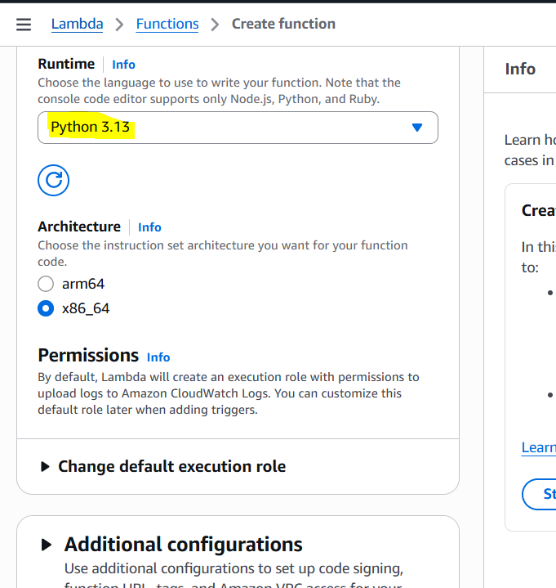

Using the Available Sample python code for testing.
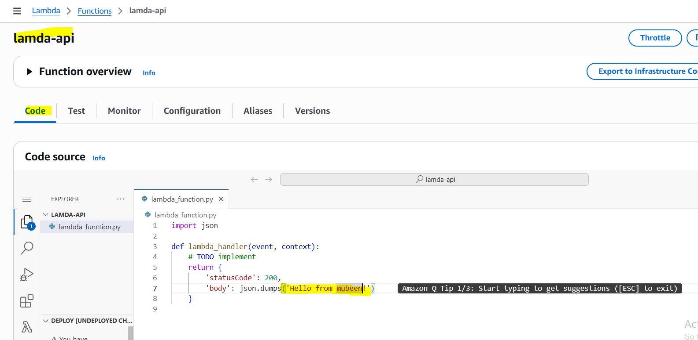
Then click on Deploy.
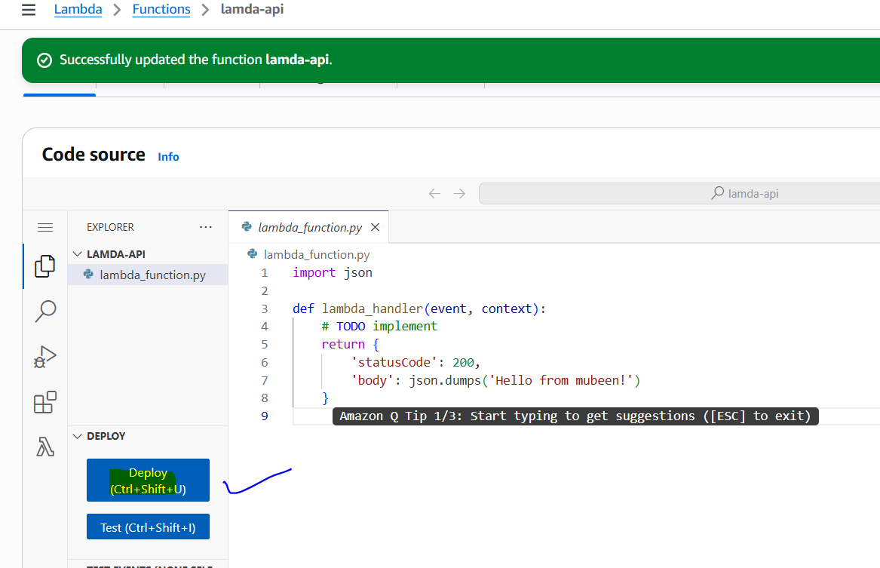

Now go to the API Gateway Dashboard and click on Create API th
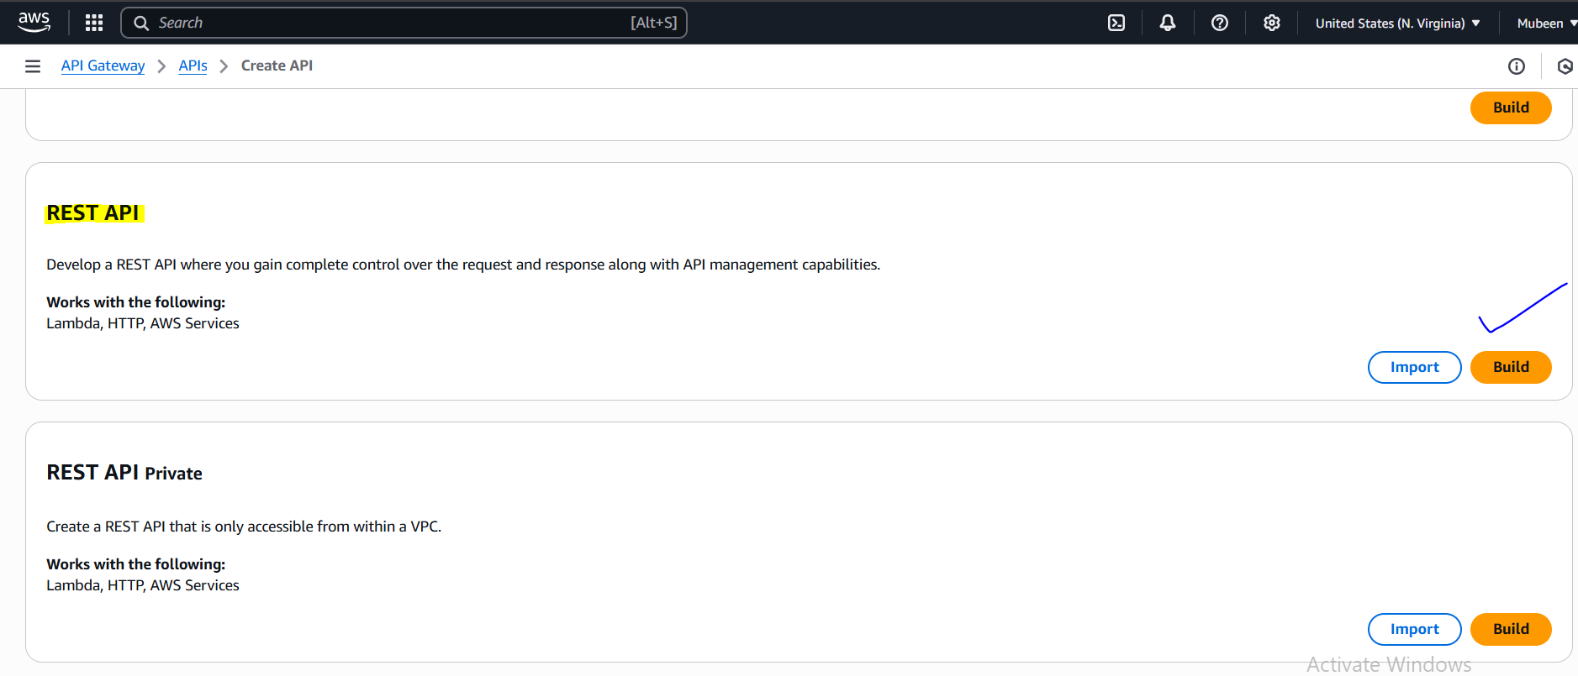

Select New API and name it as a LAMDA-API. Select endpoint type as Regional and click on create API.
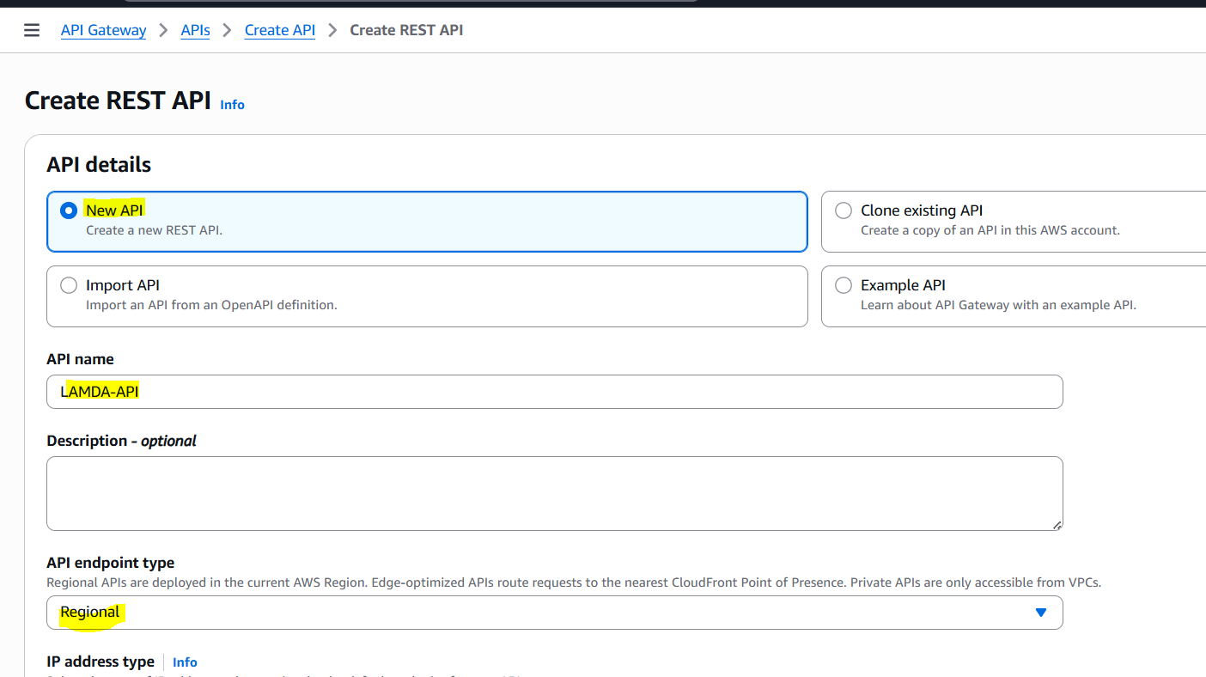

Now click on Create method.
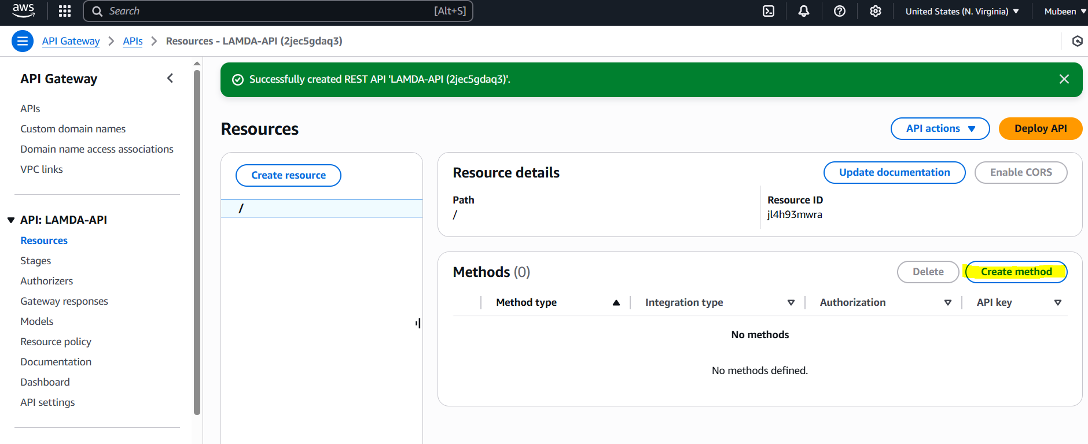

Select Method type GET with integration to Lambda function.
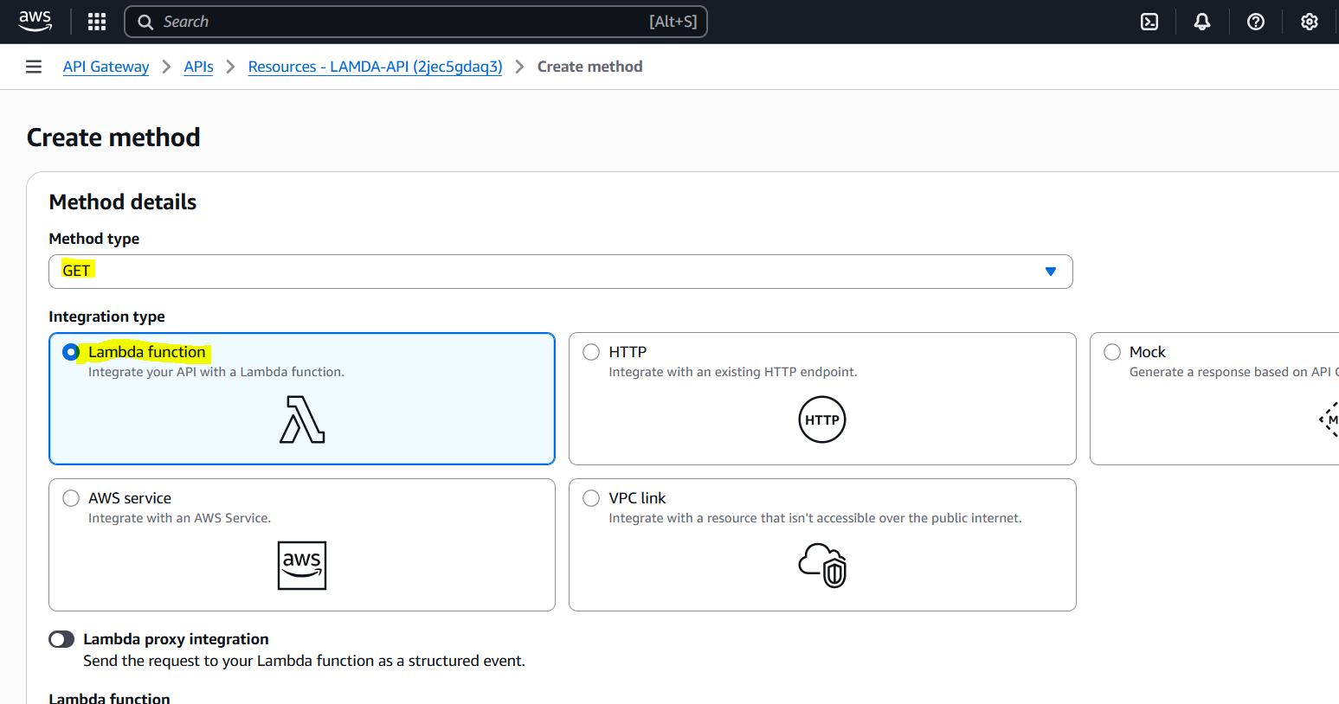
Select the Lambda which we created and click on Create method.
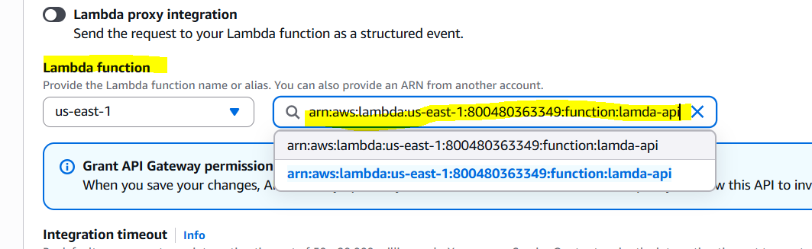
This is how it will Work.
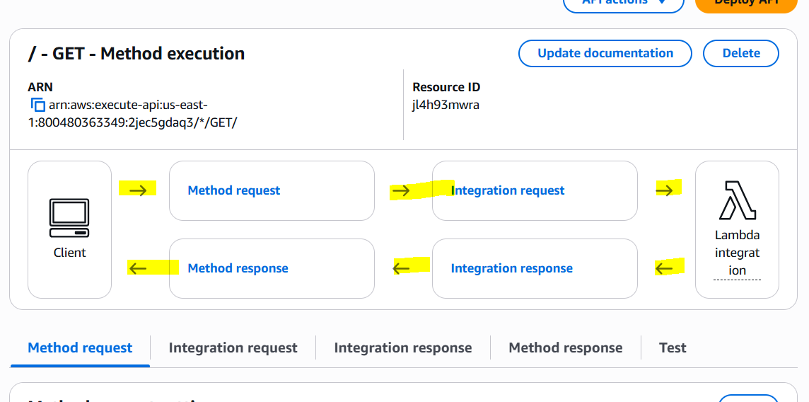

Now click on Deploy API.
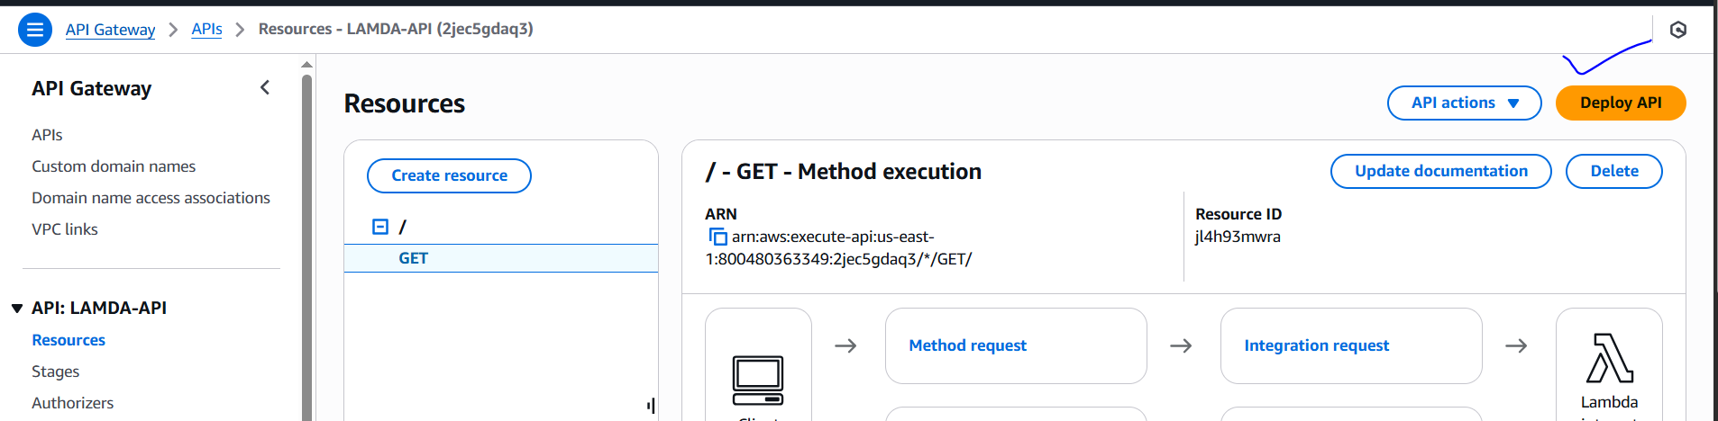

Select new Stage and name it as a test. Now click on Deploy.
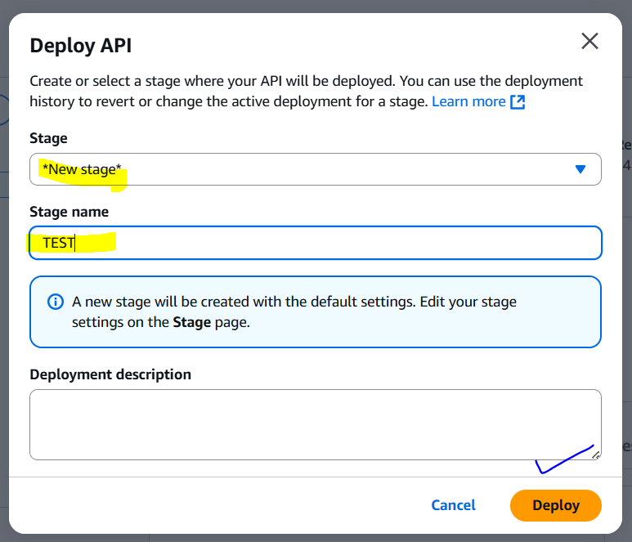
Copy this Invoke URL and paste it to the browser.
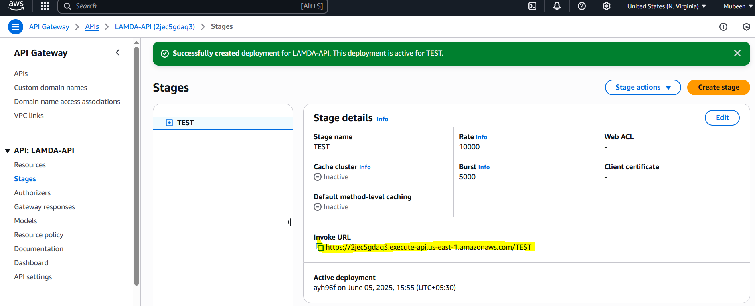

We can see the output.
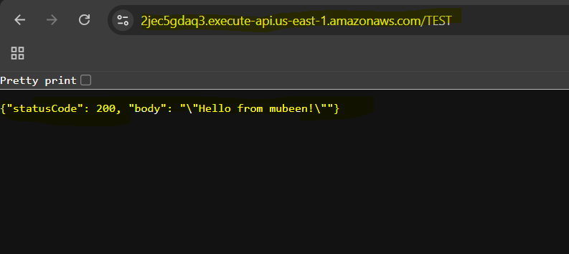

AWS Key Management Service (KMS)

1. What is AWS KMS?
A managed service that helps you create, store, and control encryption keys used to protect your data.

2. Why Use KMS?
To easily encrypt data in AWS (like in S3, RDS, Lambda, etc.) with strong security and centralized key management.

3. Where is KMS Used?
Used across AWS — encrypting S3 objects, EBS volumes, database data, Lambda environment variables, and more.

4. How Does KMS Work?
You create keys (CMKs), then AWS services or your app uses them to encrypt/decrypt data.

5. Types of Keys
- Customer Managed Keys (CMK): You control them.
- AWS Managed Keys: AWS creates and manages for you automatically.

6. Costing
Free for AWS-managed keys. For customer keys, you're charged per key per month + per encryption request.

7. Security
Uses FIPS 140-2 validated hardware. You can control access to keys using IAM and key policies.

8. Automatic Integration
Easily integrates with S3, RDS, EBS, Lambda, etc. Just enable encryption in the service settings.

9. Auditing and Logging
Works with CloudTrail to log every time a key is used (who, when, how).

10. Best Practices
Use least-privilege access, rotate keys, enable logging, and separate keys by purpose (e.g., prod vs test).

Simple task on AWS KMS configuring S3 Bucket.
While creating bucket we can see that S3 Buckets have Encryption By default.
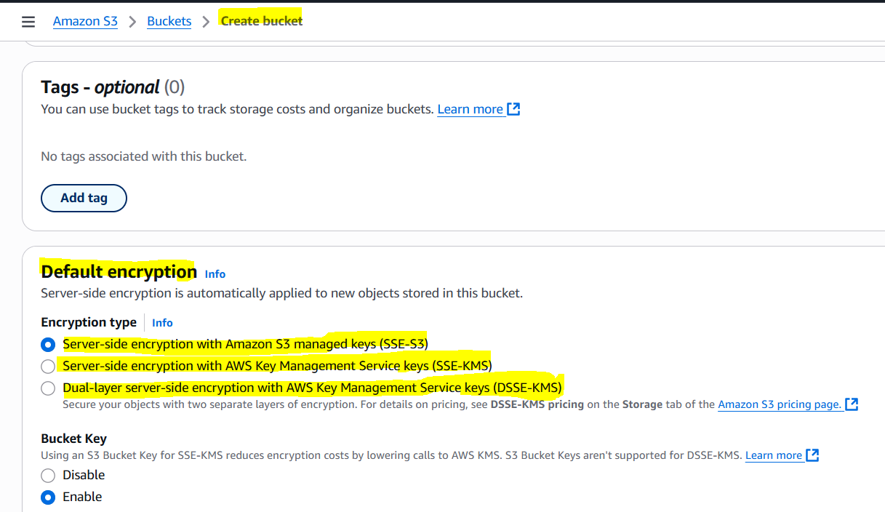
Any how if we use SSE-S3 and SSE-KMS (AWS MANAGED KEYS) Bucket objects can be accessed by user within the Account.
So, we need to create CMK (Customer managed Keys).
Create Customer managed Key type symmetric and usage Encrypt and decrypt the click on Next.
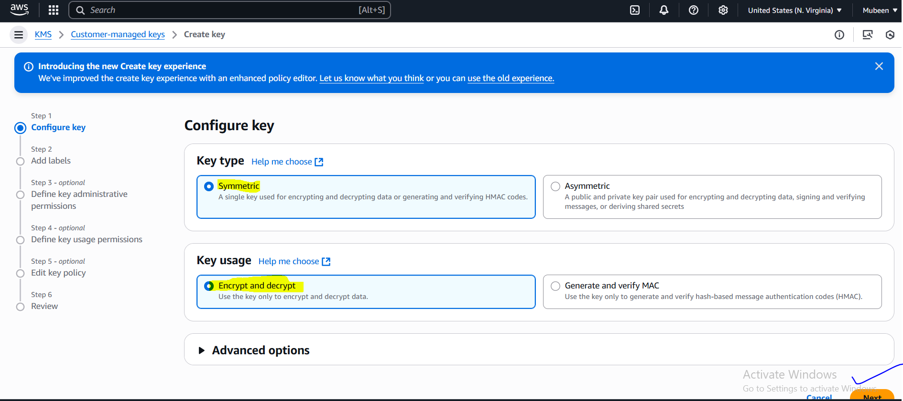

Add Alias as kms-test the click on Next.
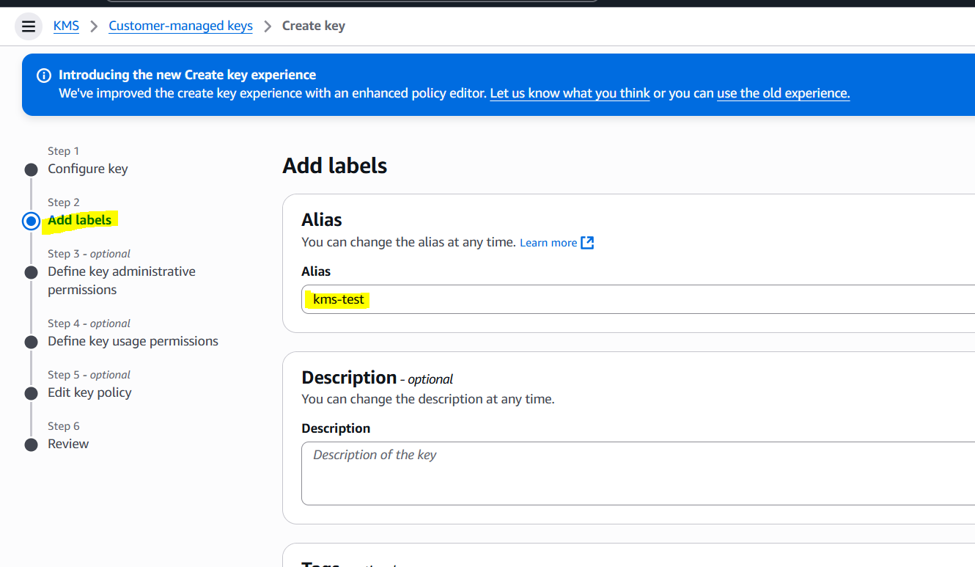
Giving Administrative permissions to particular user Devops only, then click on Next.
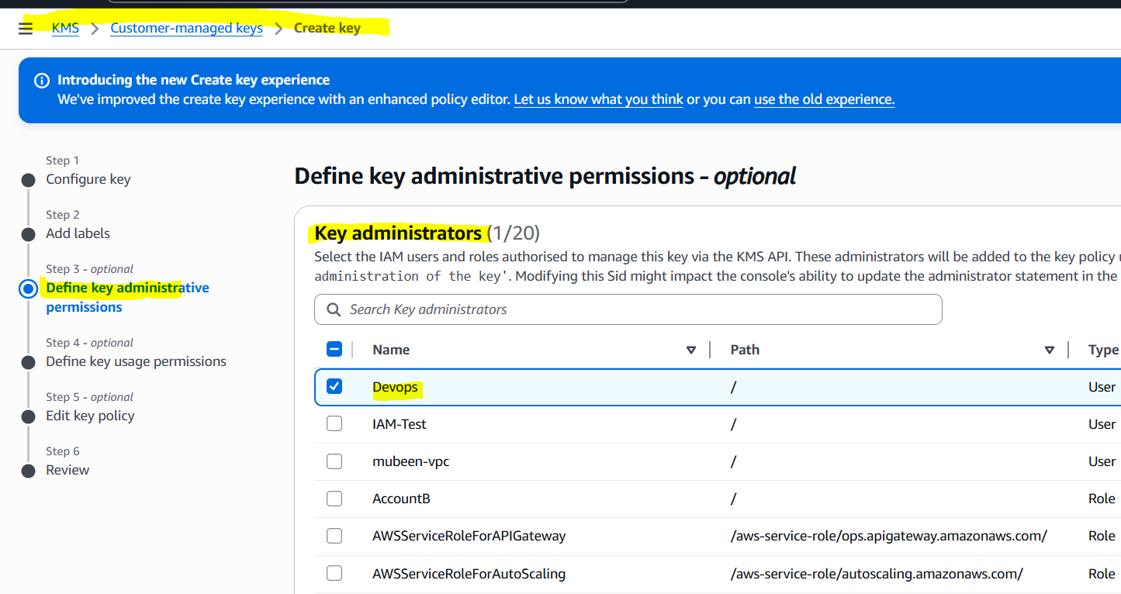

Giving Key usage permissions also to user Devops, then click on Next.
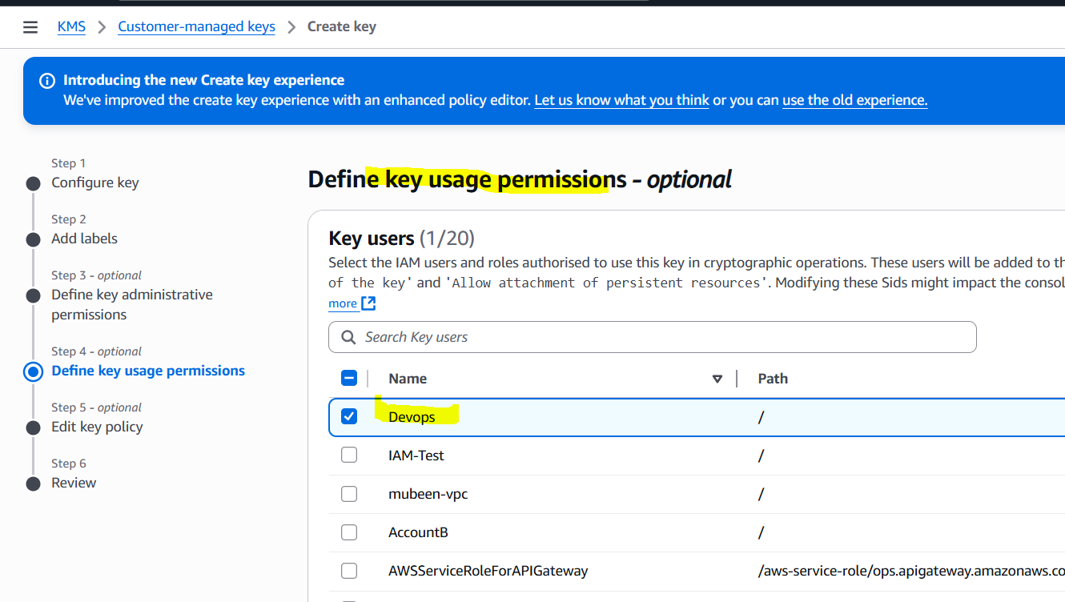

Review the policy click on Next.
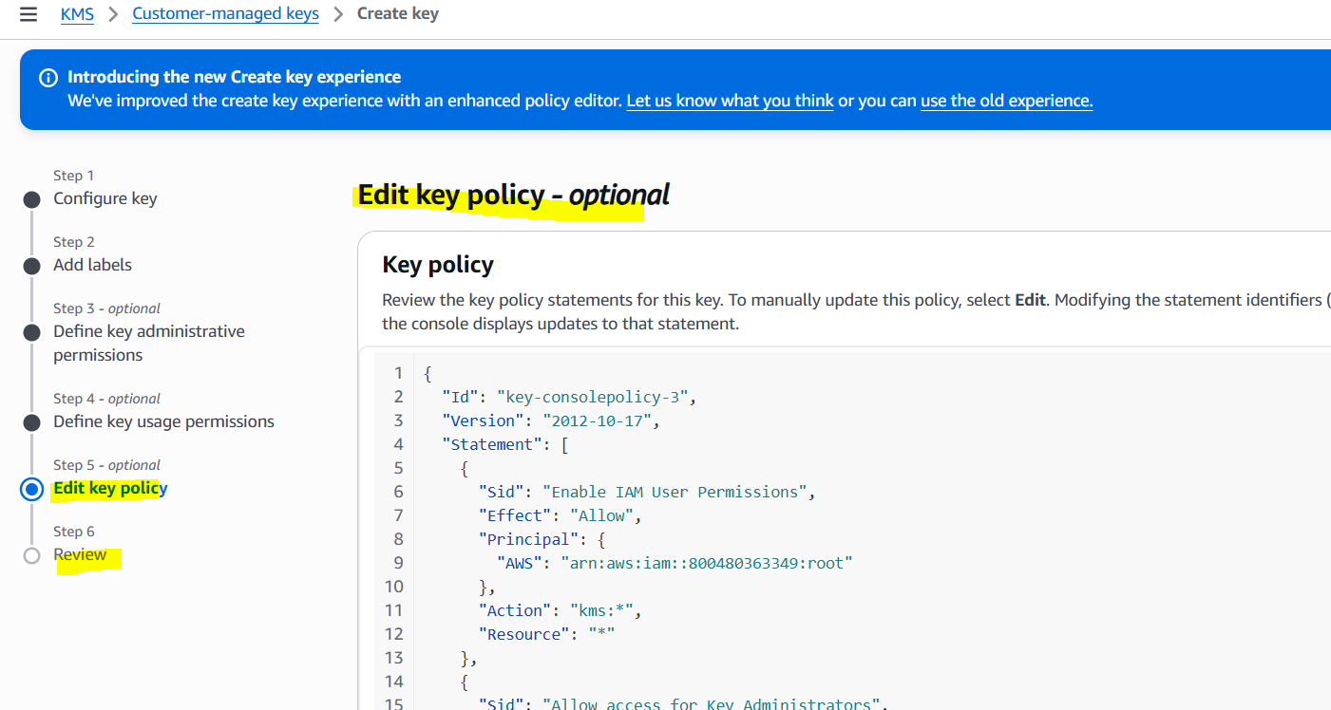

Successfully created
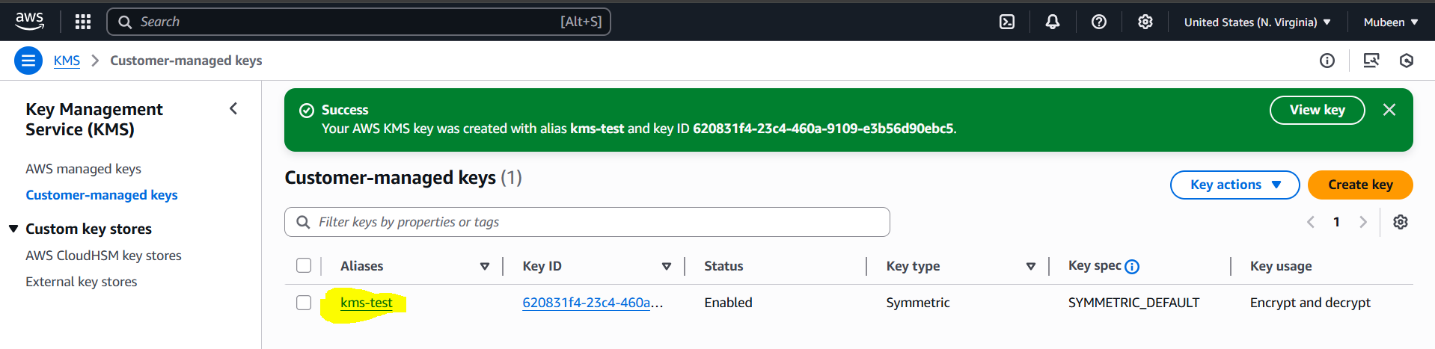

Now attaching new created CMK to the bucket, Bucket – Properties.
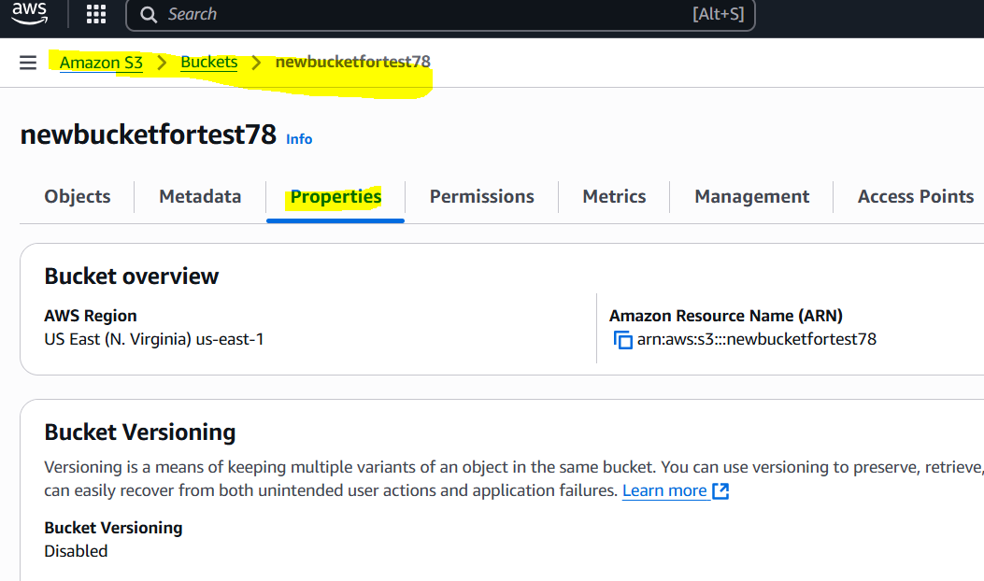

Edit Default Encryption.
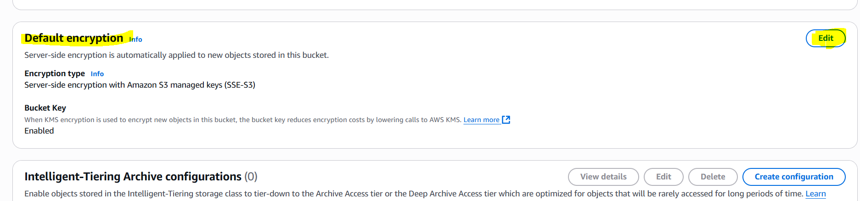

Update the created CMK and Save changes.
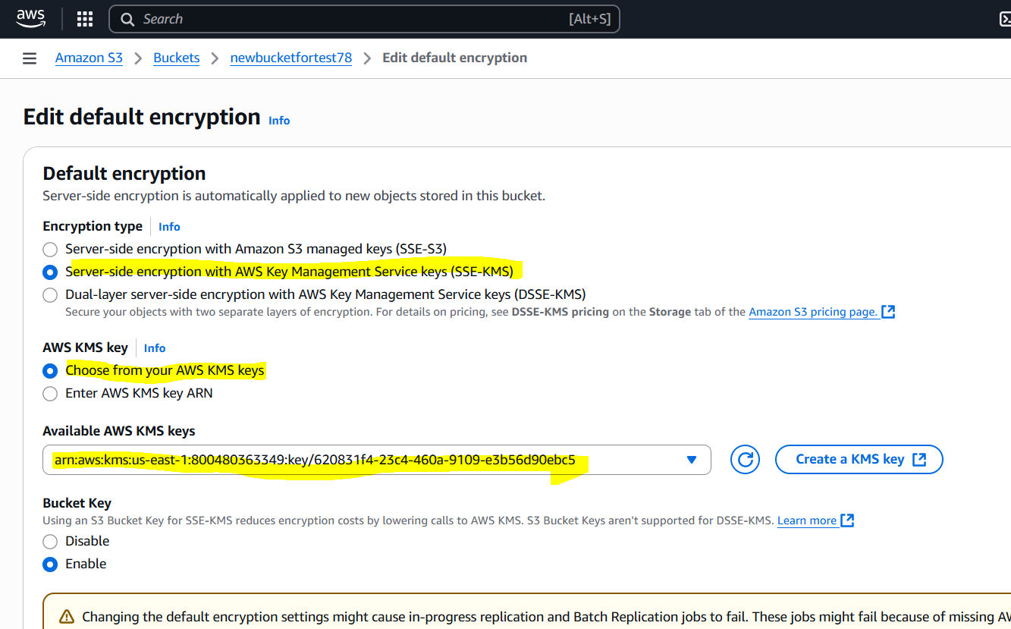

Adding new object to our bucket.
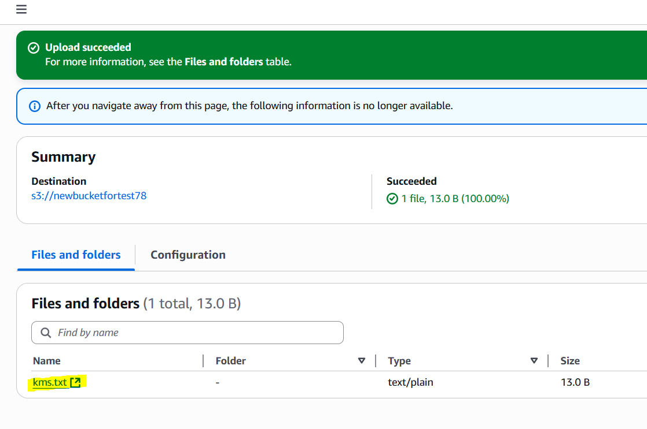
We have Given permissions to Devops user while creating CMK. So we can login as the Devops user and any other to check whether we have access or not.
Devops – user
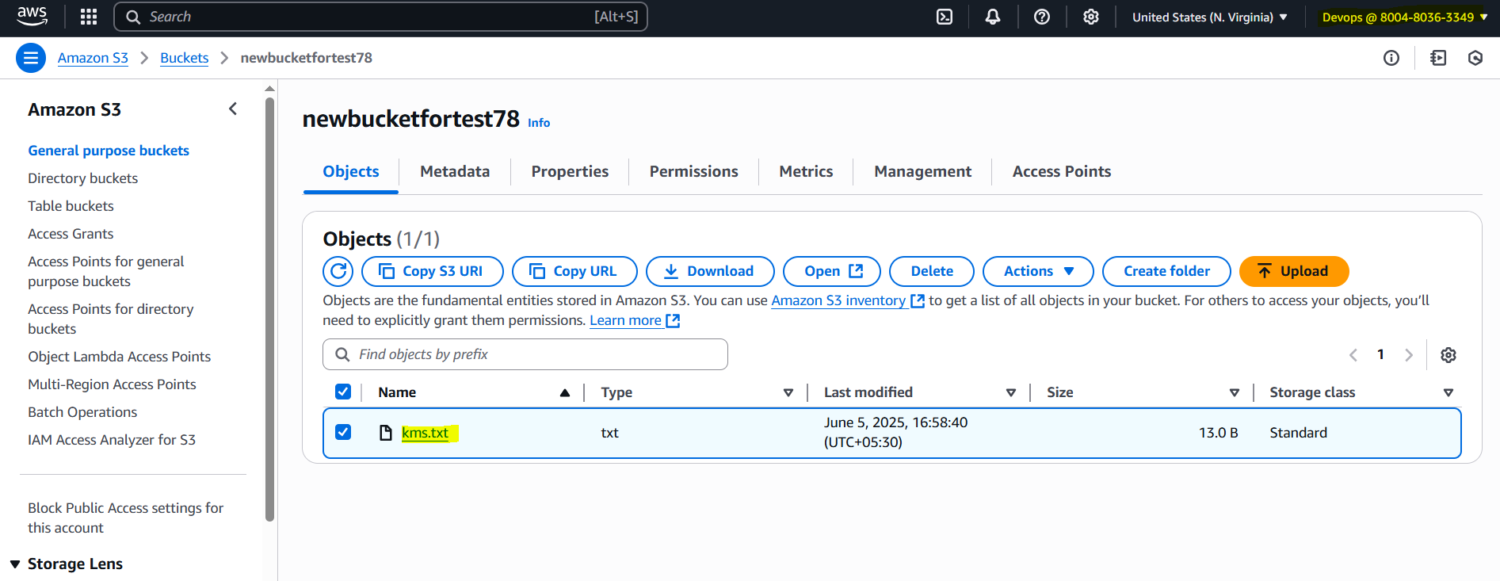
We can see that Devops user is having access.
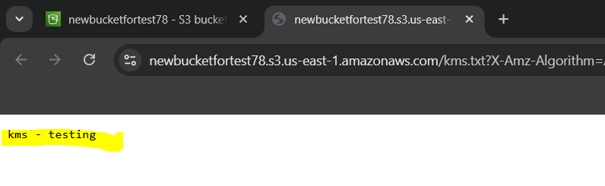

Other user.
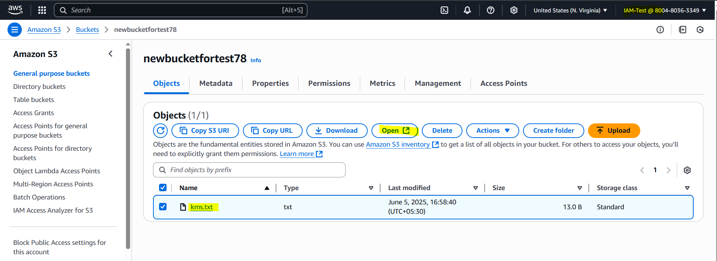

We can see that this user doesn’t have access.
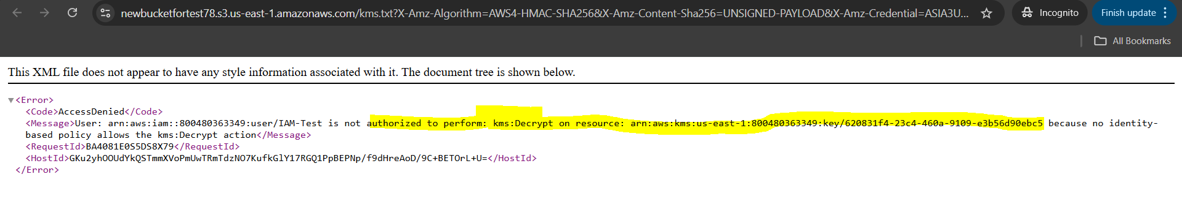

AWS SQS:

1. What is AWS SQS?
A message queuing service that lets components of your app communicate asynchronously and reliably.

2. Why Use SQS?
To decouple services, improve scalability, and handle traffic spikes without losing messages.

3. Where is SQS Used?
Between microservices, Lambda functions, EC2 instances, or backend systems needing asynchronous processing.

4. How Does SQS Work?
One system sends a message to a queue, and another system picks it up later for processing.

5. Types of Queues
- Standard Queue: High throughput, best-effort ordering, at-least-once delivery.
- FIFO Queue: Ordered and exactly-once delivery (slower but strict).

6. Durability
Messages are stored redundantly across multiple AWS zones, ensuring high availability.

7. Costing
Pay per million requests and payload size. First 1 million requests/month are free.

8. Integration
Works with Lambda, EC2, SNS, Step Functions, and more for processing and automation.

9. Security
Supports IAM policies, encryption with KMS, and access controls to protect messages.

10. Best Practices
Use FIFO for order-sensitive tasks, dead-letter queues for failed messages, and long polling to reduce empty responses.

Task on AMAZON SQS:
Go to the SQS Dashboard and click on Create queue.
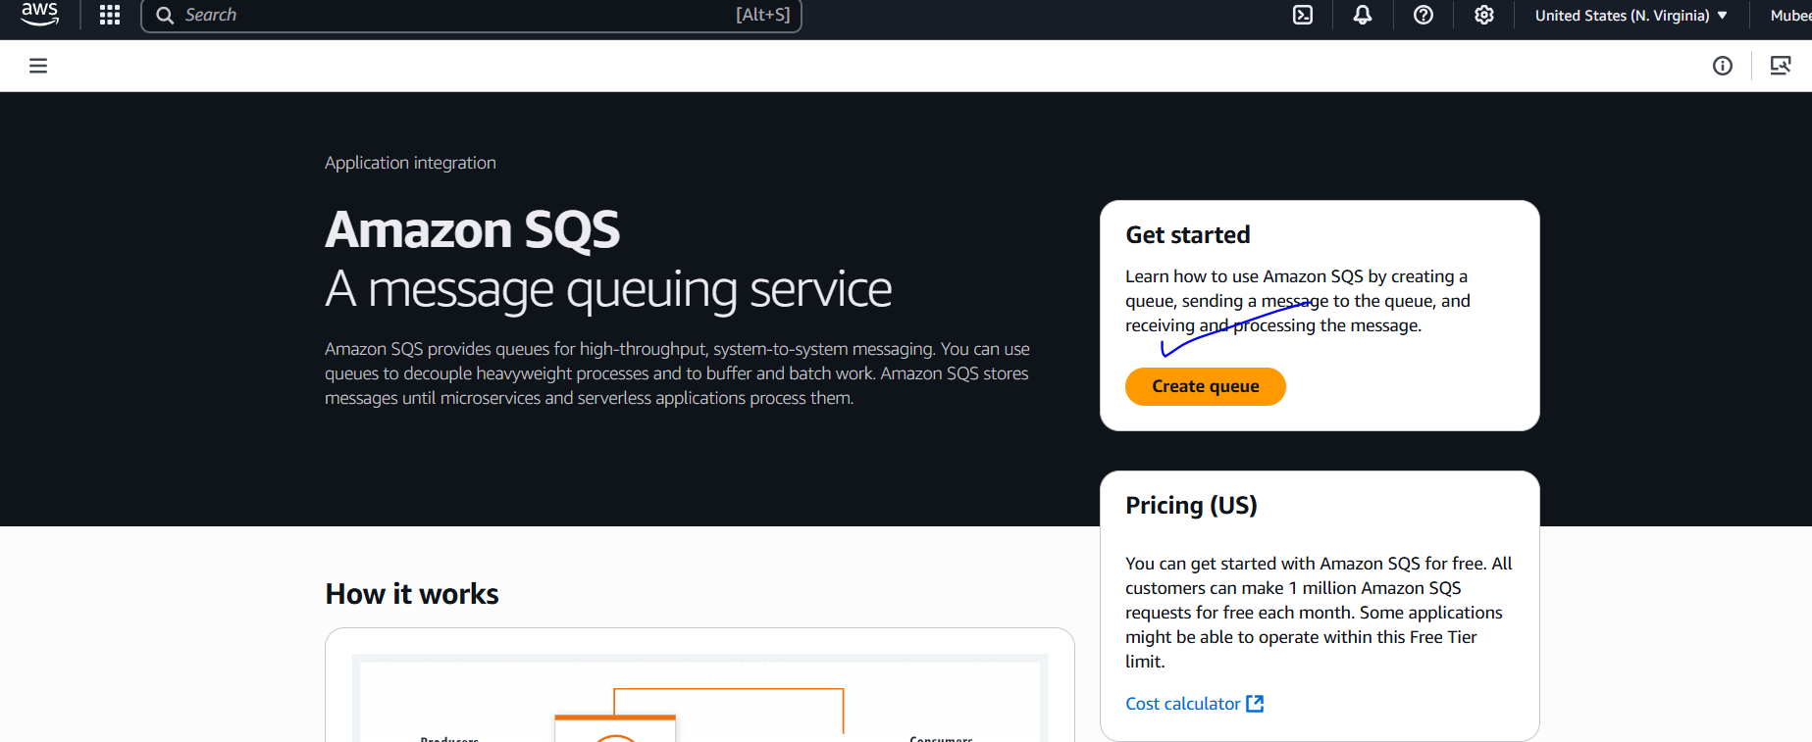
Select Standard and name it.
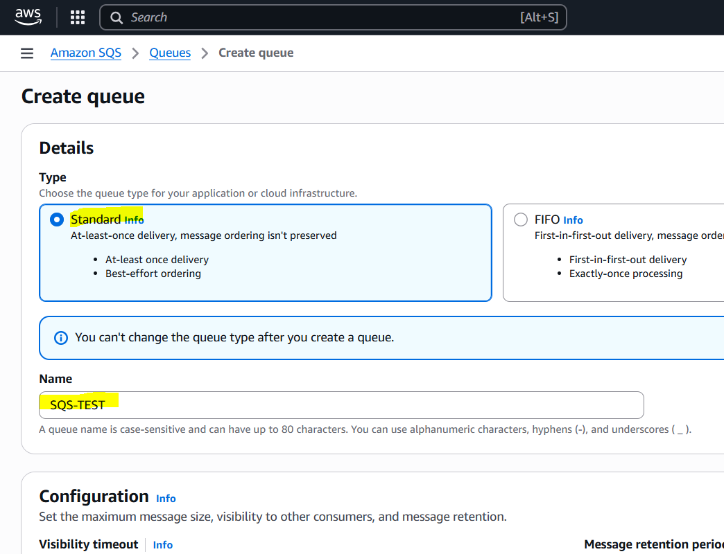
Configure as required.
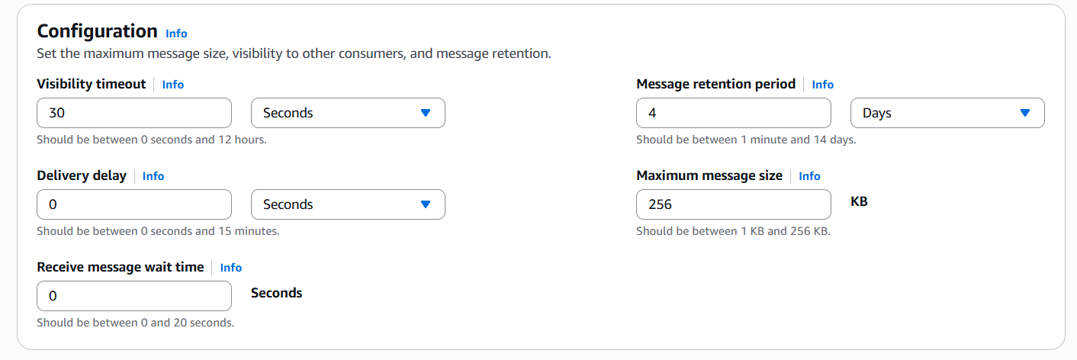

We can Encrypt and adjust policies as permissions required.
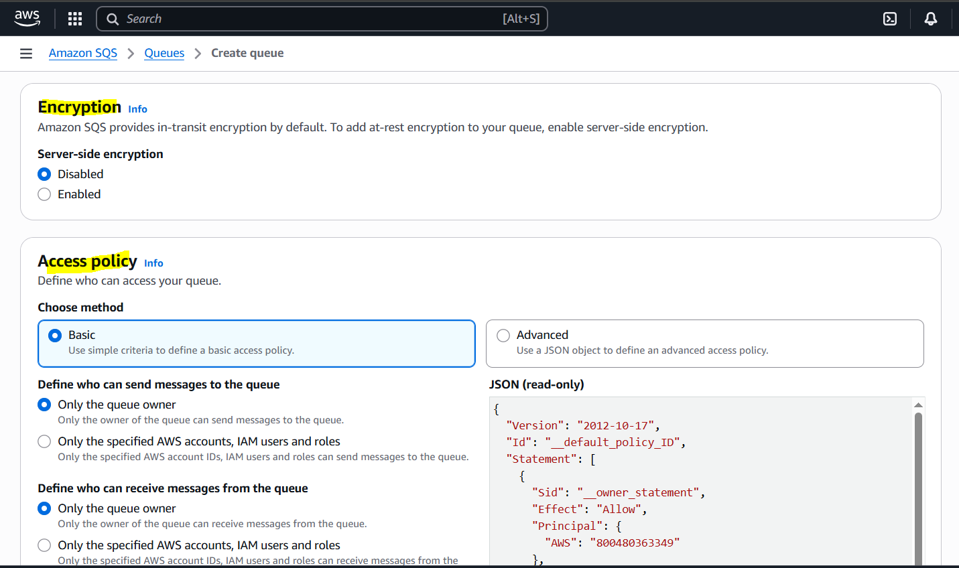
After checking optional settings Click on create.
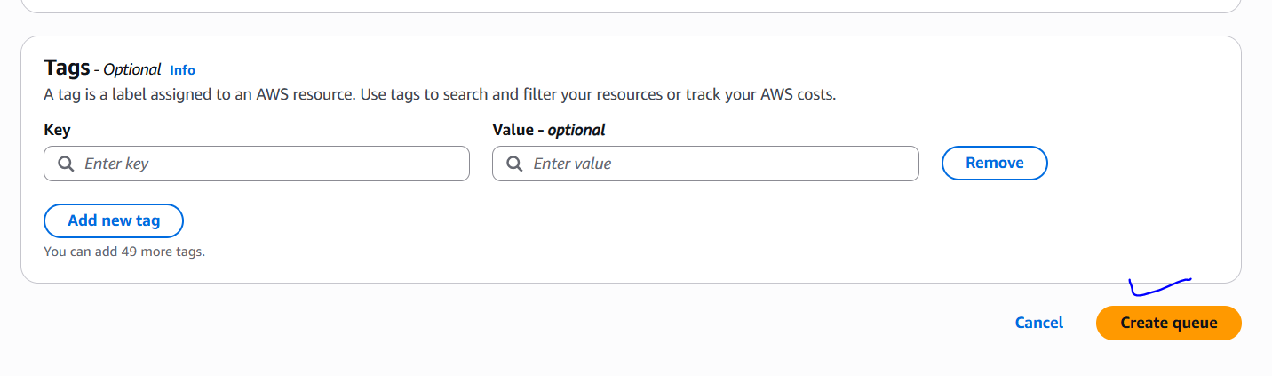
We can configure these options with our SQS.
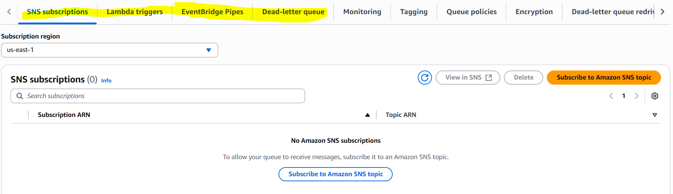

For testing click on send and receive messages.
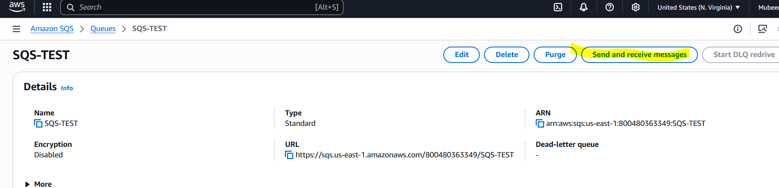

Write the message and click on send.
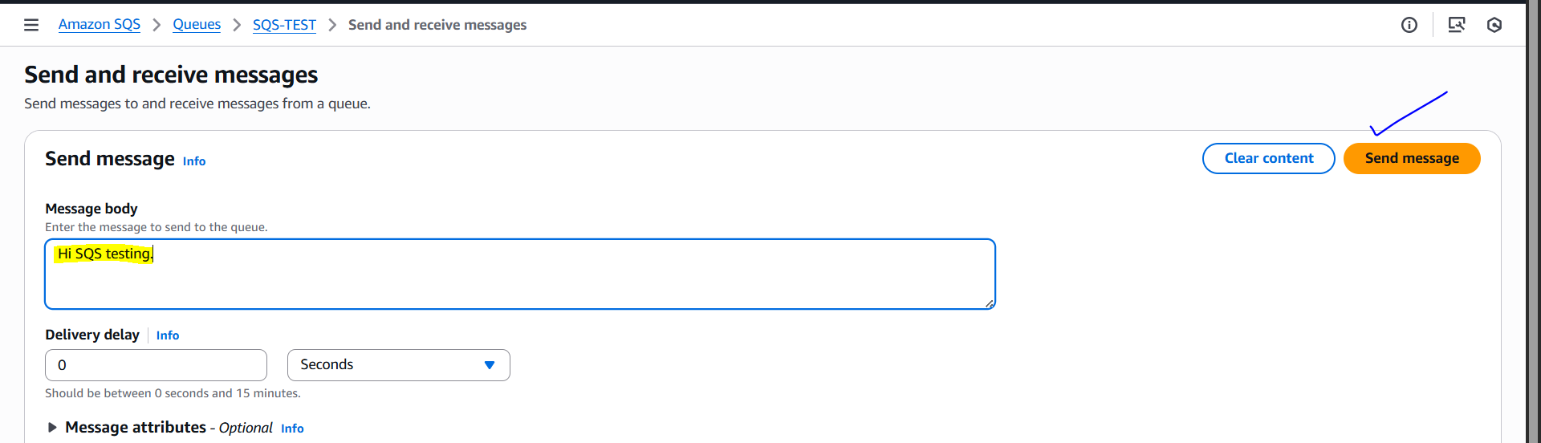
Scroll down to Receive messages and click on poll for messages to check messages.
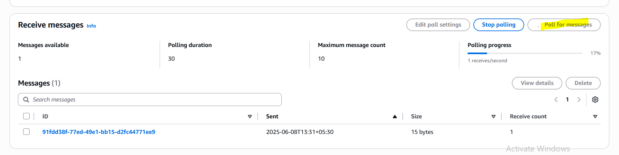

We can see the message here.
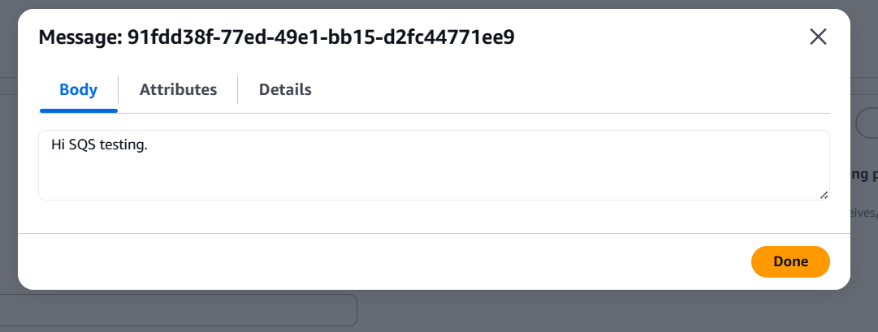

Amazon MQ

1. What is AWS MQ?
A managed message broker service that supports industry-standard protocols like Apache ActiveMQ and RabbitMQ.

2. Why Use AWS MQ?
To easily set up and operate message brokers for complex messaging patterns without managing infrastructure.

3. Where is AWS MQ Used?
In applications requiring message queuing, pub/sub, streaming, and reliable communication between distributed components.

4. How Does AWS MQ Work?
AWS manages the broker infrastructure; your apps connect via standard protocols (JMS, AMQP, MQTT, etc.) to send/receive messages.

5. Supported Brokers
- Apache ActiveMQ
- RabbitMQ

6. Durability and Availability
Supports multi-AZ deployments for high availability and message durability.

7. Costing
Charged by broker instance hours and storage used.

8. Security
Supports VPC, encryption at rest and in transit, IAM policies, and access control.

9. Integration
Integrates with EC2, Lambda, containers, and on-prem systems using standard messaging protocols.

10. Best Practices
Choose the right broker type (ActiveMQ or RabbitMQ) based on your app needs, monitor broker health, use encryption, and scale broker instances as needed.

Task on AMAZON MQ:
Go to the Amazon MQ Dashboard and click on Get started.
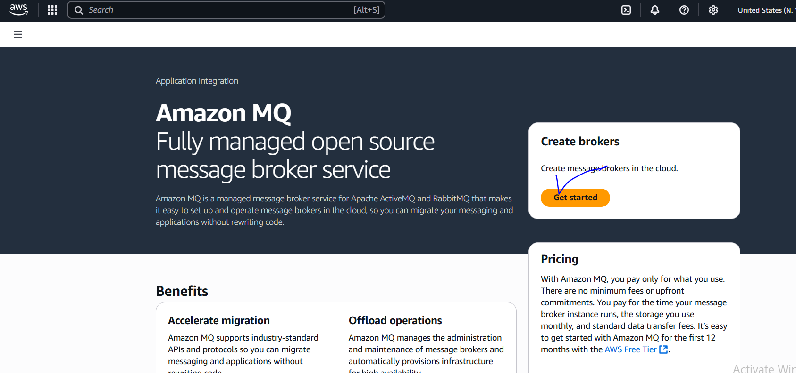
Select RabbitMQ and click on next,
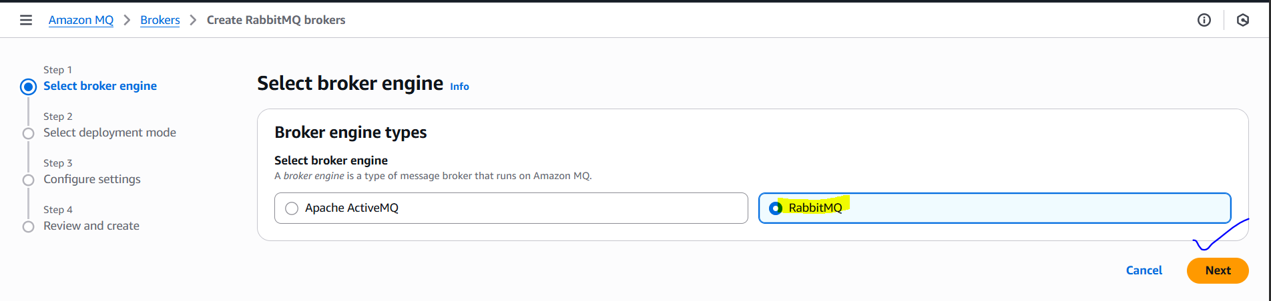
For demo selecting Single-instance broker and click on next.
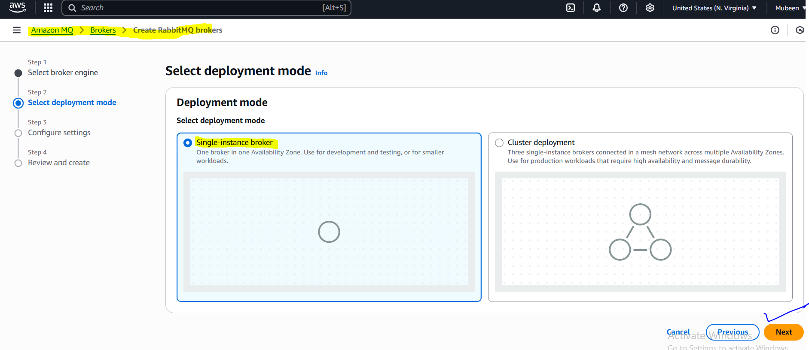
Give a name and select instance type.
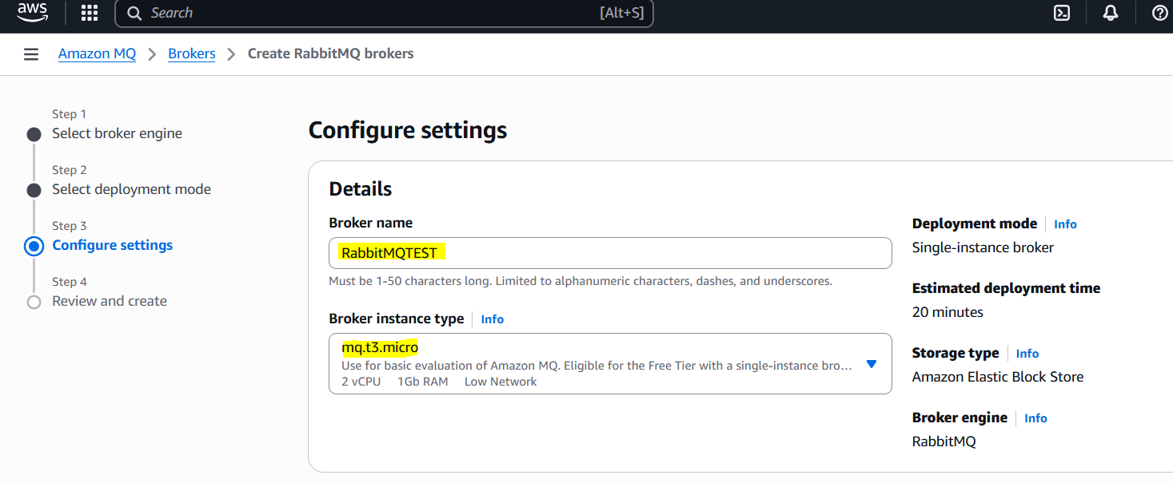
Add credentials for access.
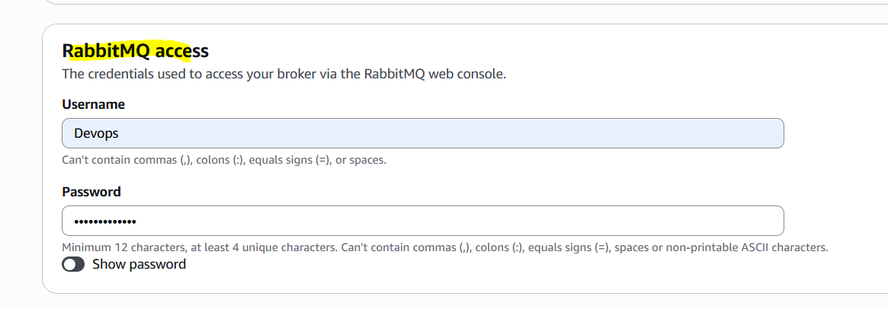
Review and click on create broker.
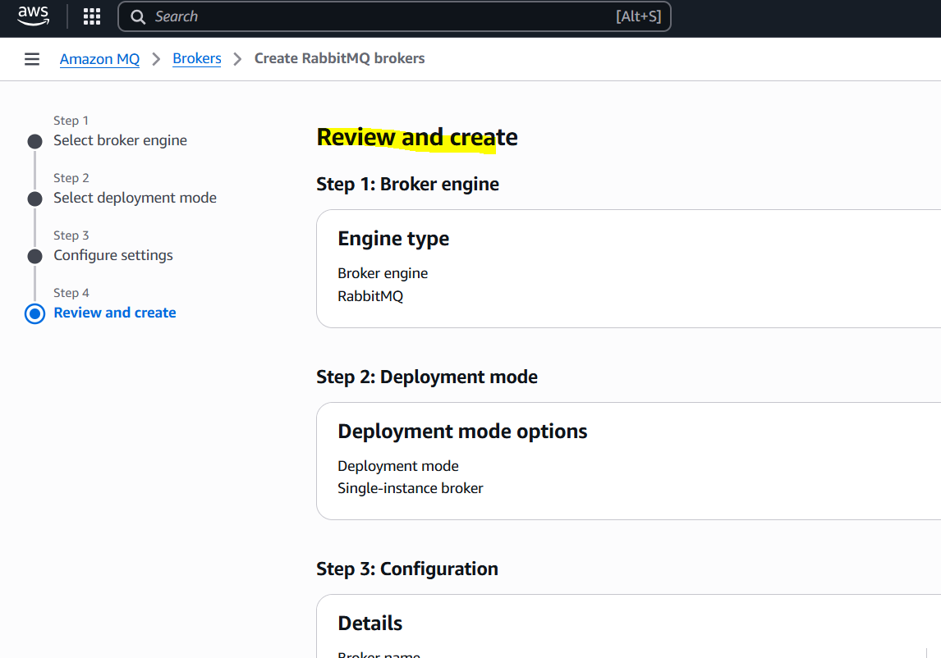
Broker is created.
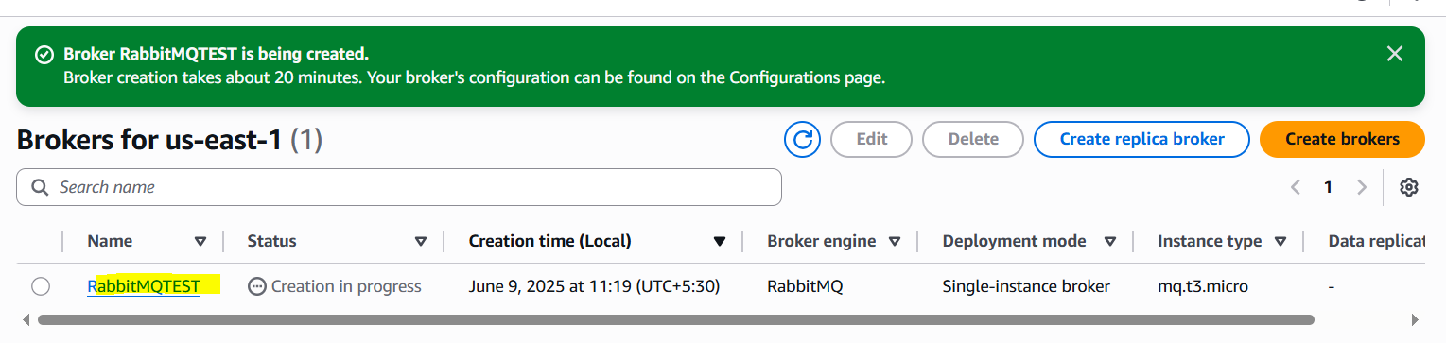
Click on this URL to connect with RabbitMQ.
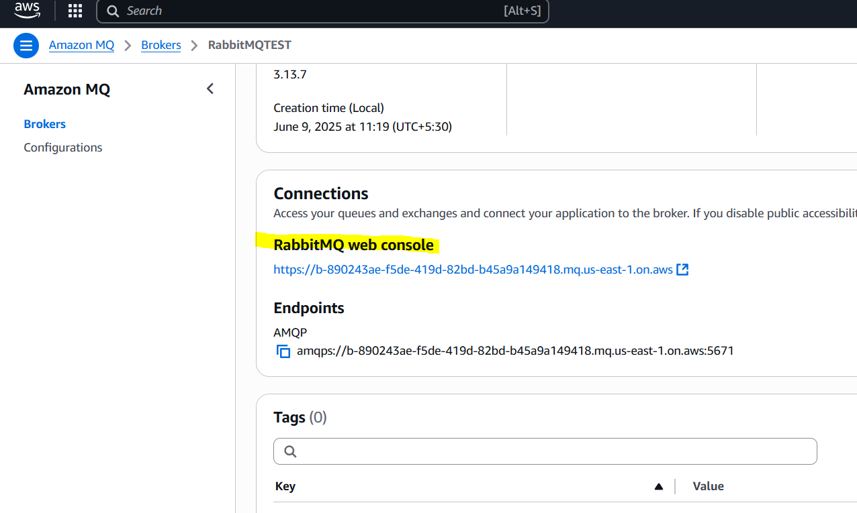
Give Credentials here and click on Login.
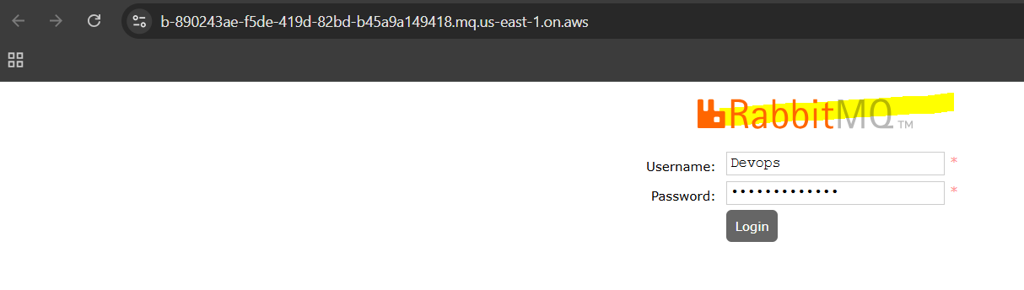

Here we can configure.
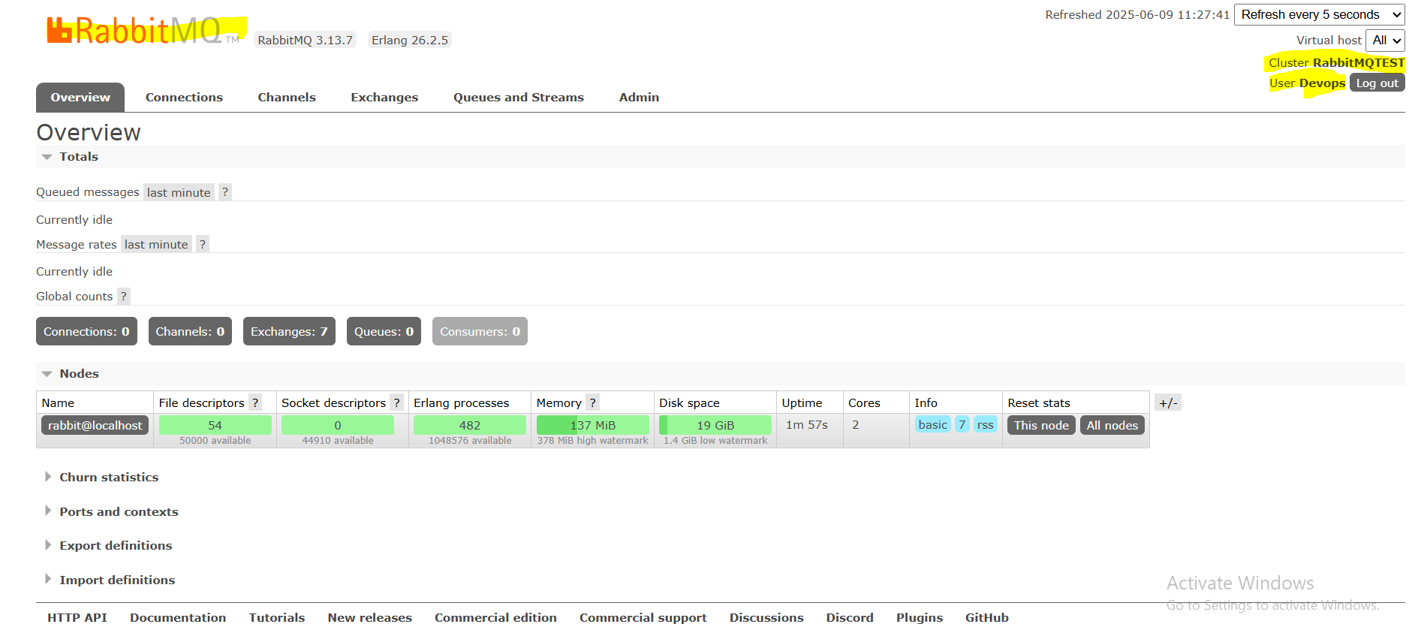

AWS Secrets Manager

1. What is AWS Secrets Manager?
A service to securely store and manage secrets like database passwords, API keys, and credentials.

2. Why Use Secrets Manager?
To avoid hardcoding secrets in code and manage them securely with automatic rotation and fine-grained access control.

3. Where is Secrets Manager Used?
Used by applications, Lambda functions, EC2 instances, and containers needing secure access to credentials.

4. How Does It Work?
You store secrets in Secrets Manager; your apps retrieve them securely via API calls when needed.

5. Secret Rotation
Supports automatic rotation of secrets using Lambda functions to improve security.

6. Encryption
Secrets are encrypted at rest using AWS KMS and encrypted in transit.

7. Access Control
Access to secrets is controlled via IAM policies and resource-based policies.

8. Costing
Charged per secret stored per month and per 10,000 API calls to retrieve secrets.

9. Audit and Logging
Integrates with CloudTrail to log all secret access and management activities for auditing.

10. Best Practices
Use rotation, restrict permissions, encrypt secrets, avoid storing secrets in code or config files.

Task on AWS Secrets Manager
Go to the dashboard of aws secrets manager and click on Store a new secret.
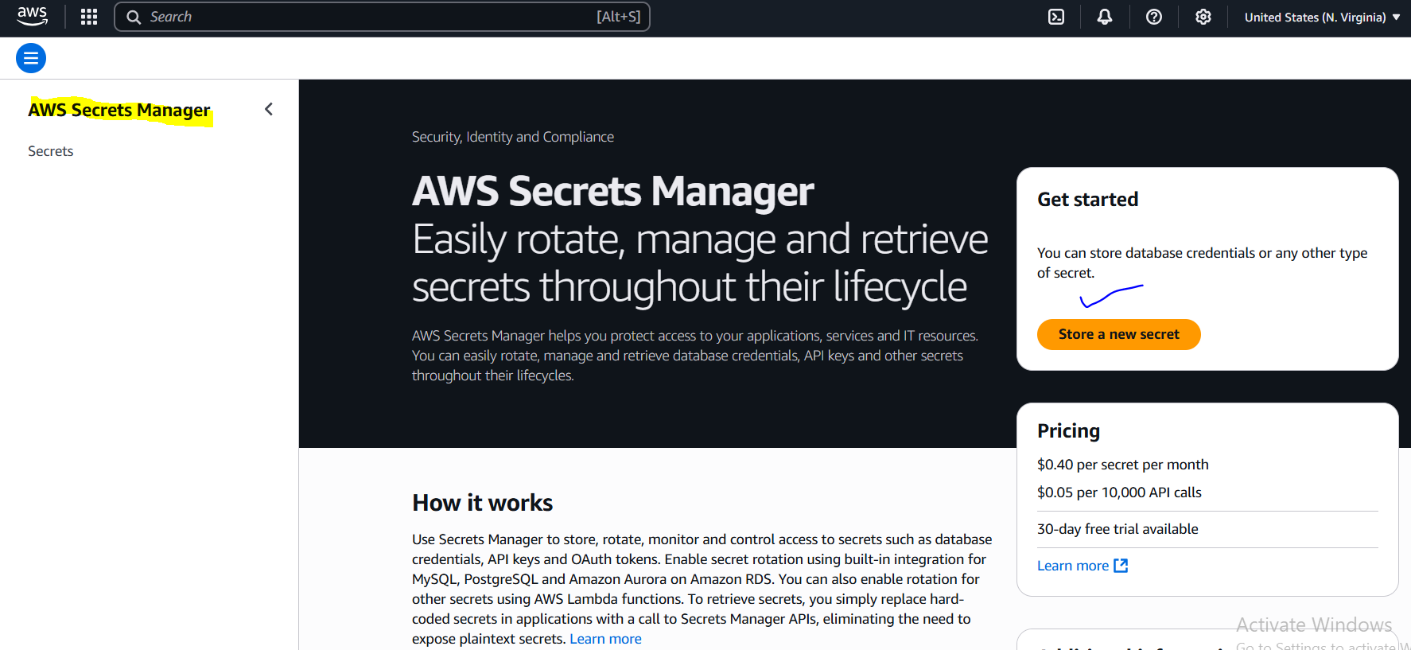
We can Store credentials of any of these resources, currently I don’t have any so I’m selecting other DB’s.
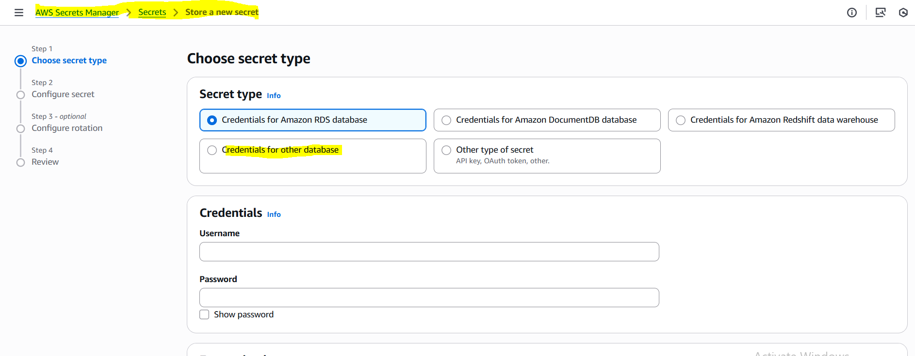

Add user name and password then in Encryption option select default key or we can create CMK.
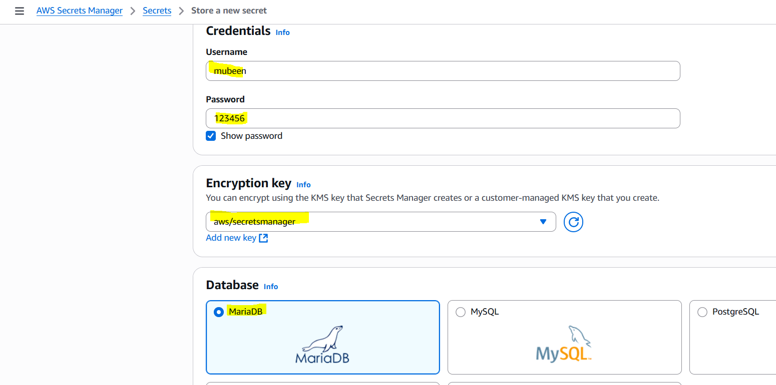

Select any DB and add Server, Database and port details then click on Next. Adding just for Demo.
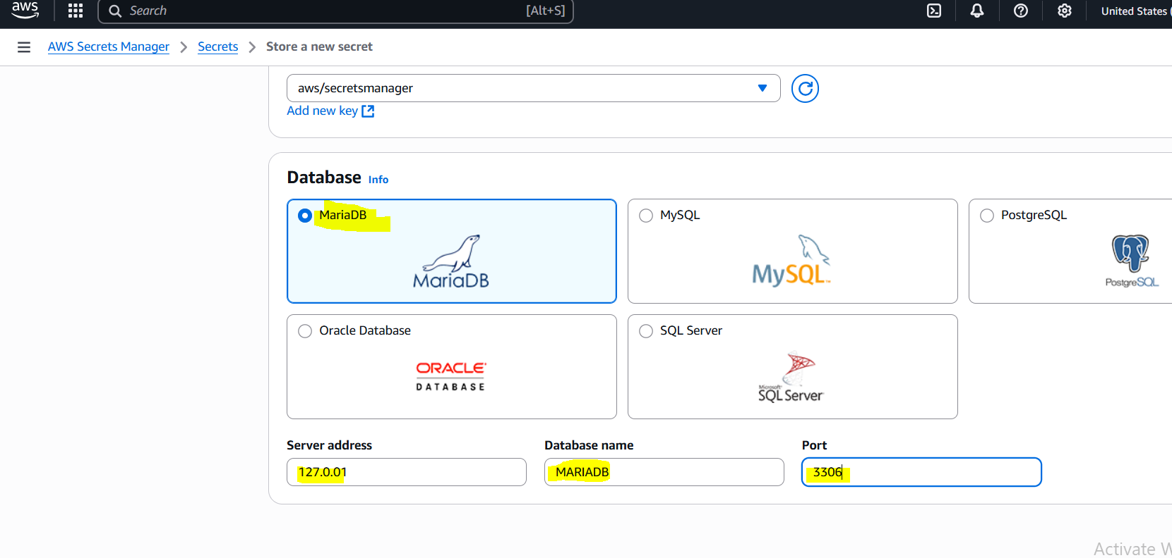

Add any secret name as per standard then click on Next.
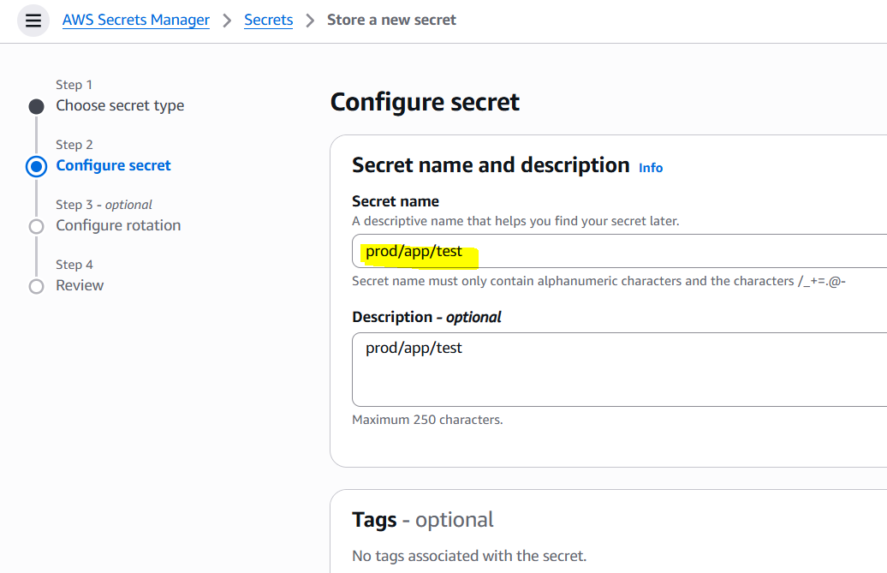

Configure rotation, Means the password should be changed after every 90 days need to add Lambda function for that. Lambda Function is mandatory for scheduling rotation.
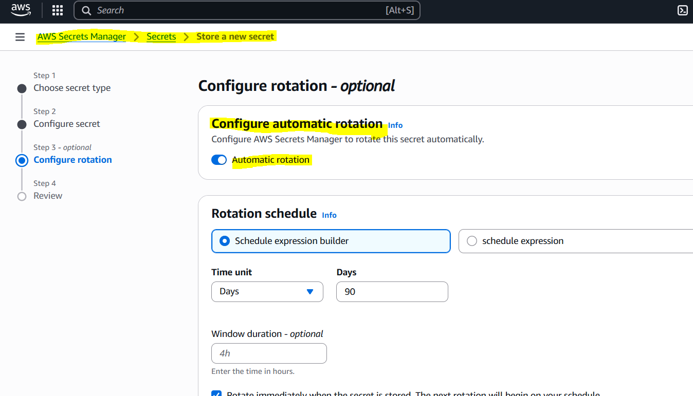
Review everything and click on Store.
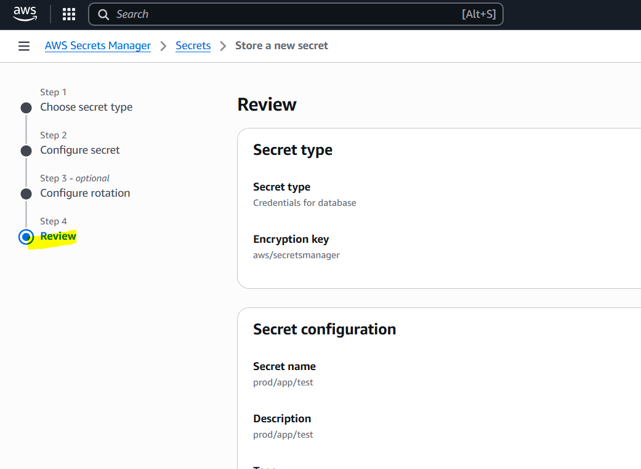
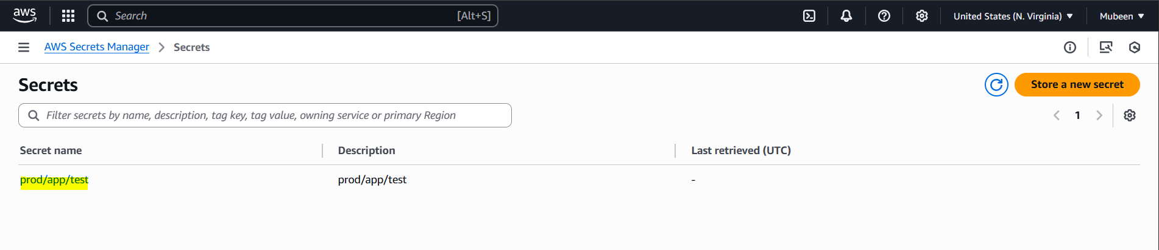

AWS Web Application Firewall (WAF)

1. What is AWS WAF?
A firewall that protects web applications from common web exploits like SQL injection, XSS, and bots.

2. Why Use AWS WAF?
To secure your websites and APIs from attacks, block bad traffic, and allow good traffic.

3. Where is AWS WAF Used?
Used with CloudFront, API Gateway, Application Load Balancer (ALB), and AppSync.

4. How Does WAF Work?
You define rules (match patterns), and WAF inspects incoming web traffic to allow, block, or count requests.

5. Types of Rules
- Managed Rules (by AWS or vendors)
- Custom Rules (your own conditions like IPs, country, headers, body)

6. Protection Features
Protects against SQL injection, cross-site scripting, IP blocking, rate limiting, bot control, geo-blocking.

7. Costing
Pay for:
- Each web ACL (firewall instance)
- Number of rules
- Number of requests processed

8. Real-Time Monitoring
Integrated with CloudWatch for logging, metrics, and alerts about attacks or blocked requests.

9. Automation
Can be configured to auto-block bad IPs or request patterns using AWS Lambda and AWS Firewall Manager.

10. Best Practices
Use managed rules, monitor logs, limit rates, test rules in “count” mode, and block only after validation.
How to Set-up AWS WAF
Go to the AWS WAF Dashboard – Getting started then click on Create web ACL.
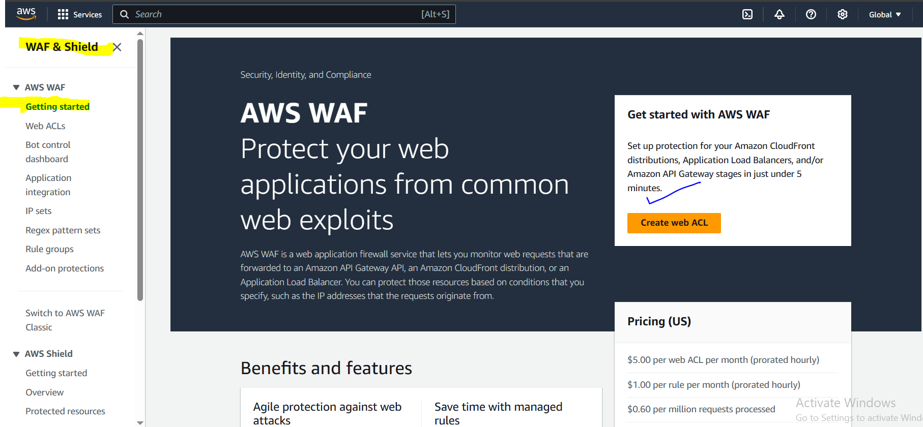

We can monitor the incoming web requests for these Global and Regional Resources.
Add name of the web ACL.
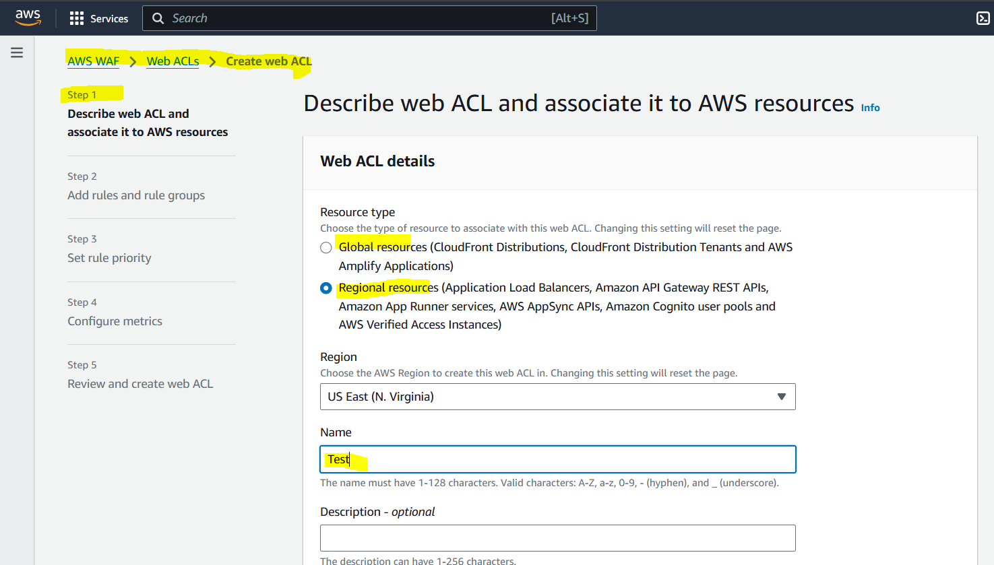

While creating the API we have to add the metric name for our API.
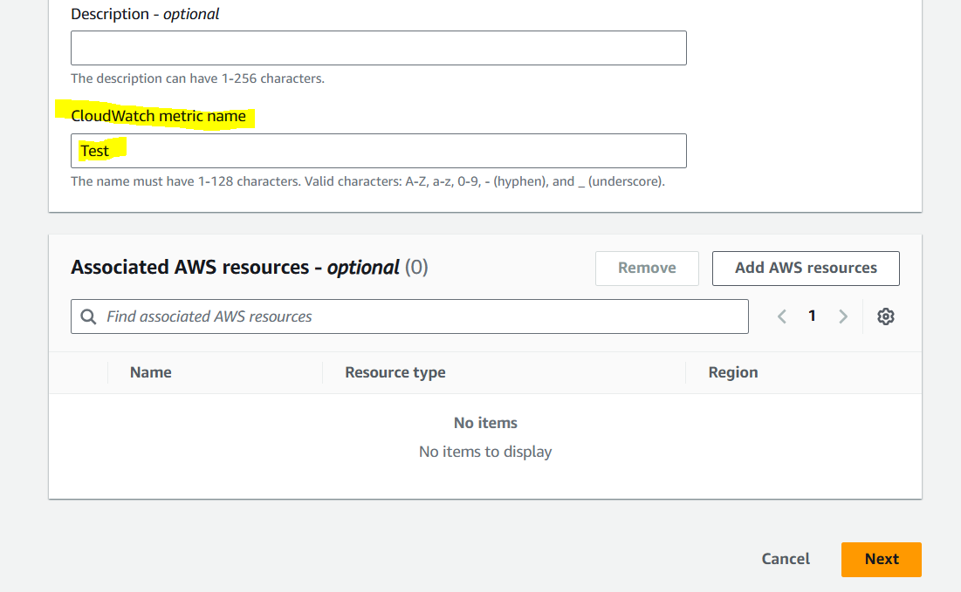

In Add AWS Resources we can select any as required, for now I’m ignoring this option and clicking on Next.
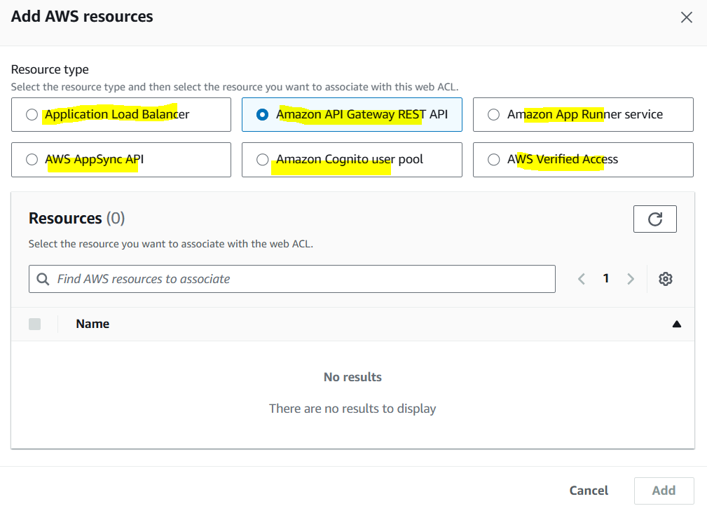

We can Add existing rules or create new rules. For now I’m going for Managed rule groups.
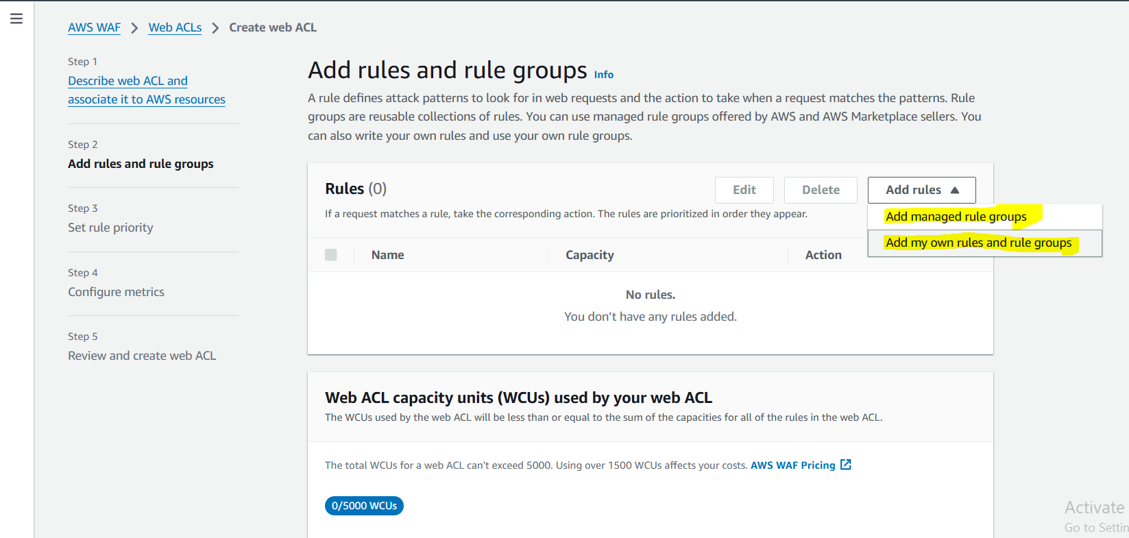
We can configure as required.
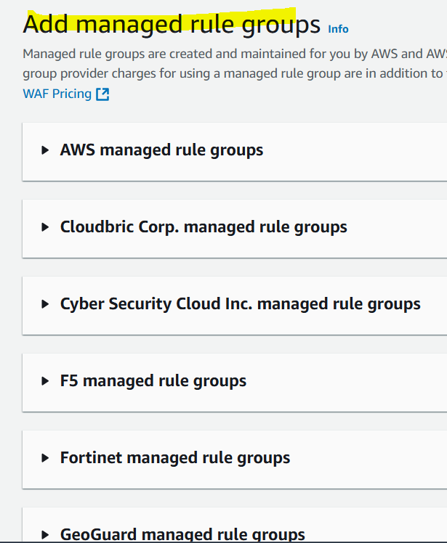

In Aws managed rule groups we have both paid and free rule groups. Going with Free rule groups.
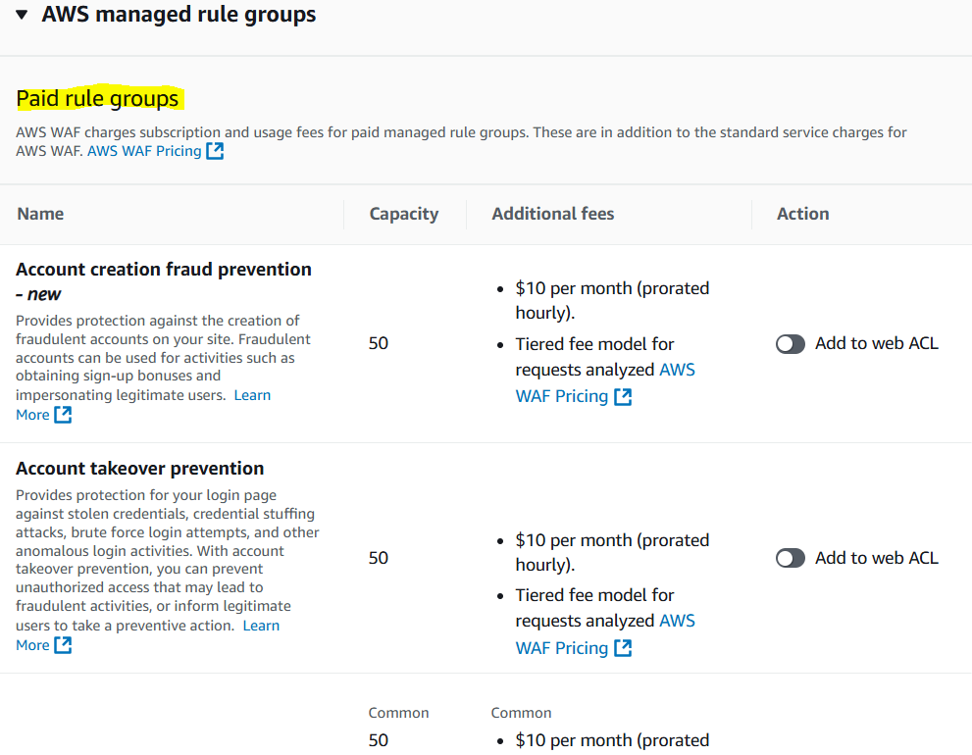
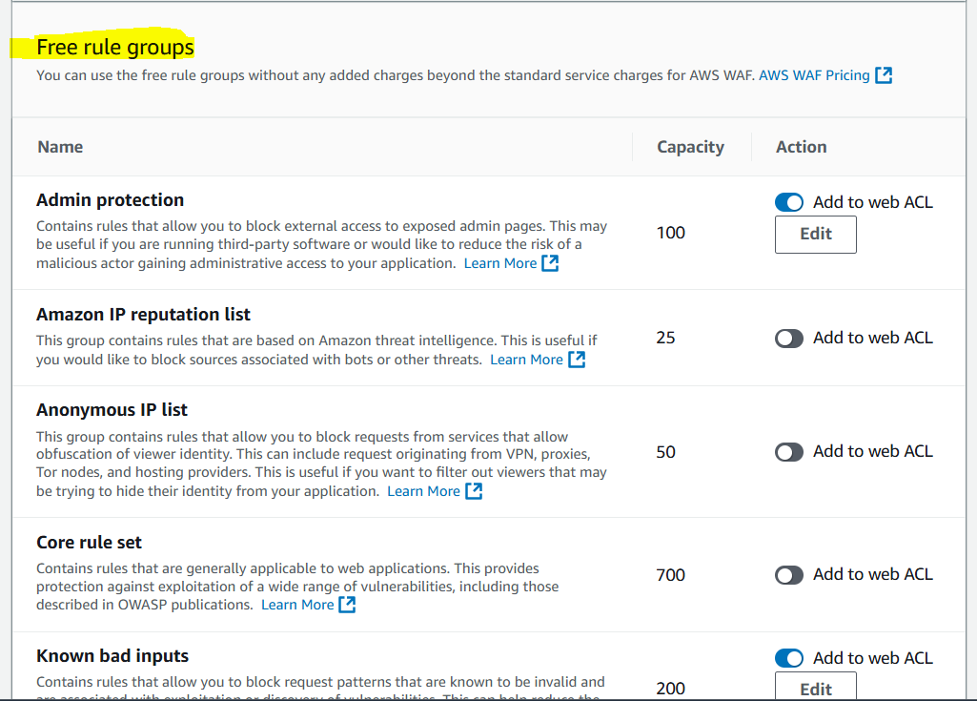
We can configure rules as per the project/app/web-app/ requirement.

Select the rules and make sure the capacity is not crossing 1500. We can configure Allow/Block to the selected ruels.
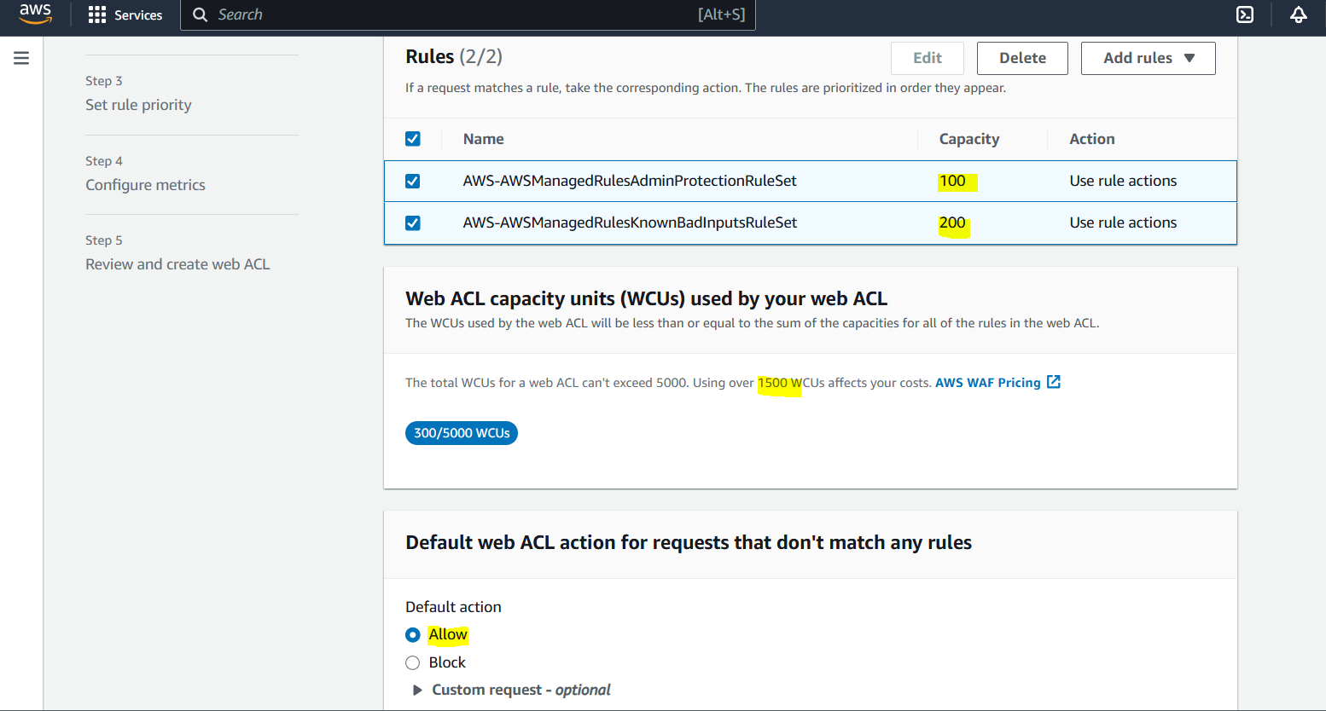

We can set rules according to the priorities.
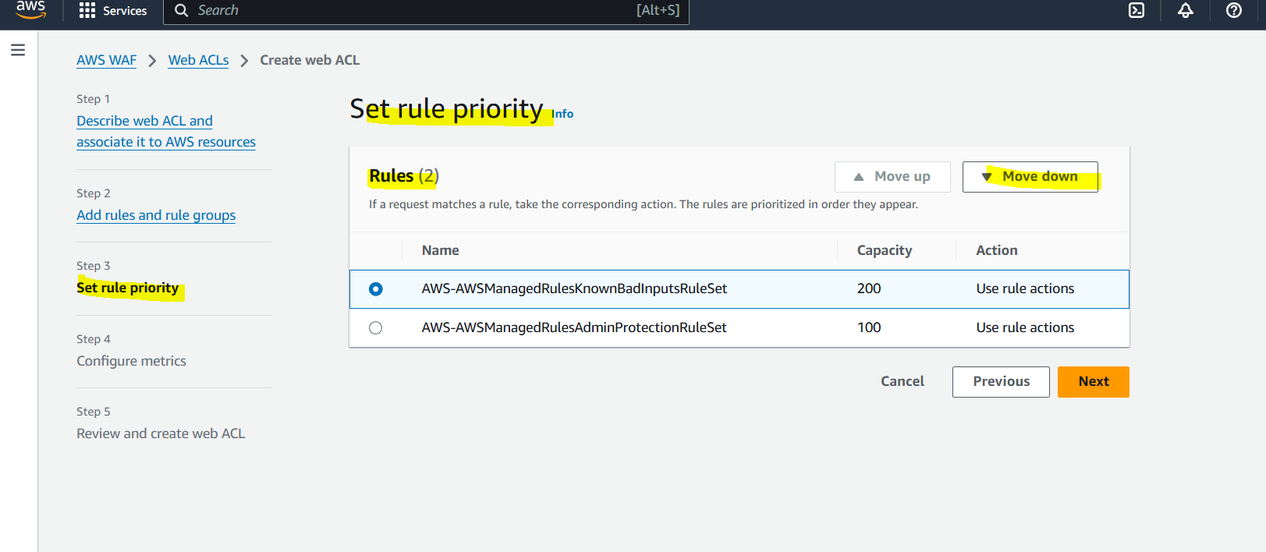
We get Metrics for the rules we are configuring.
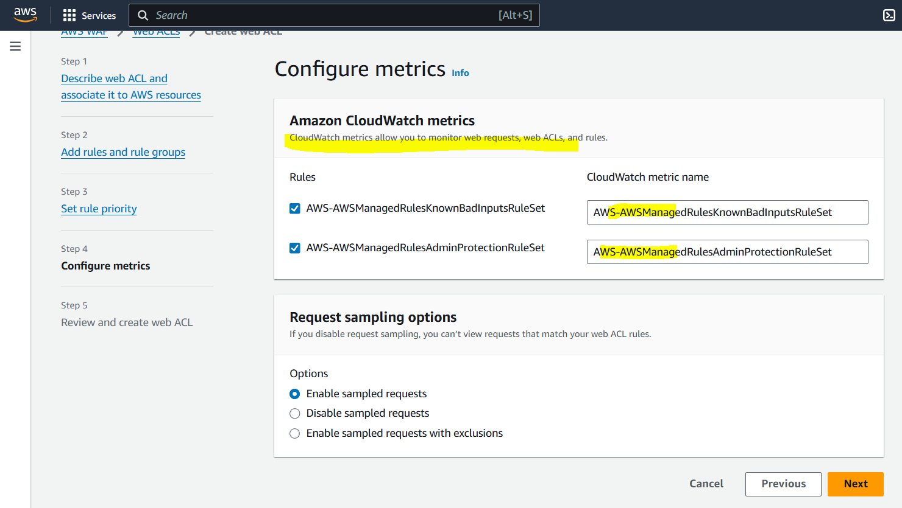

Review everything and click on Create web ACL.
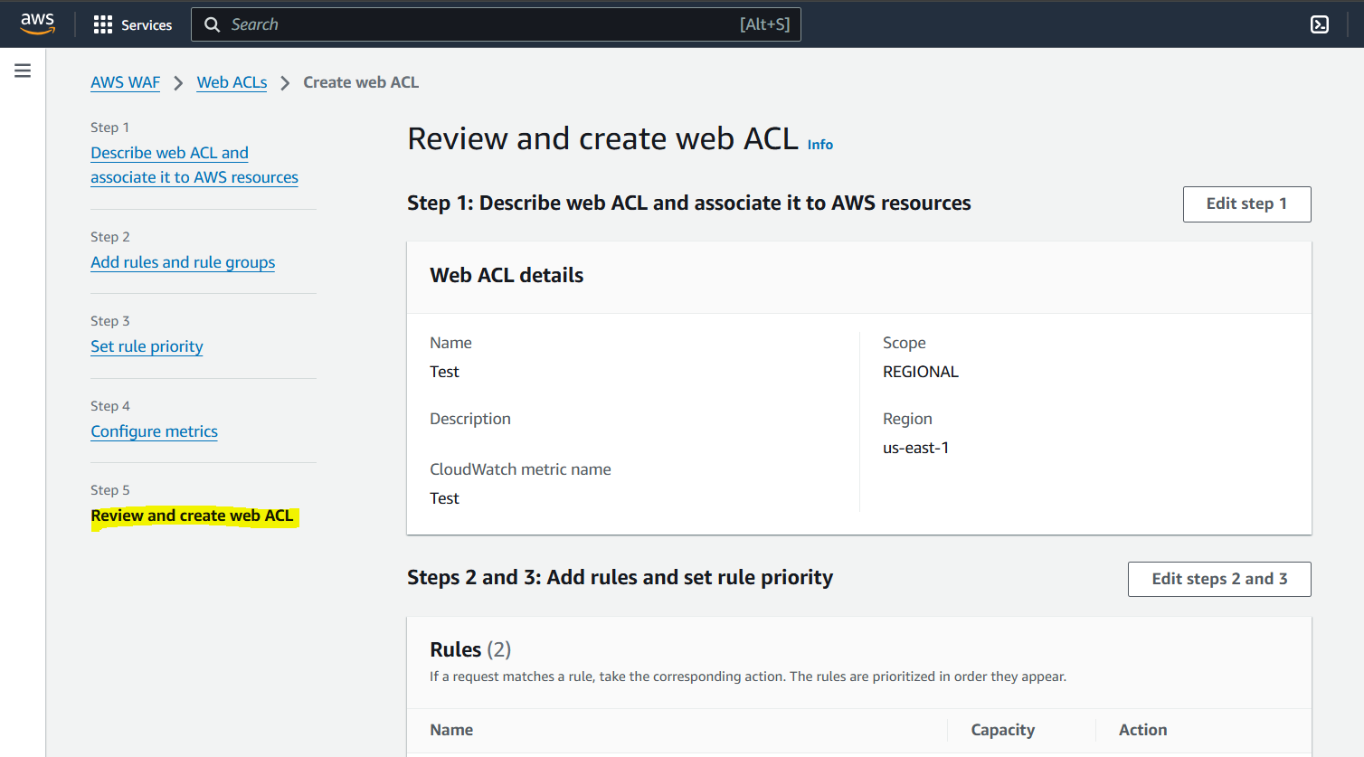

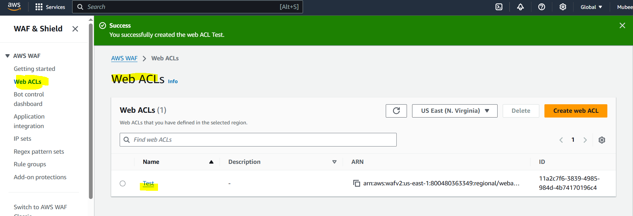

AWS Shield

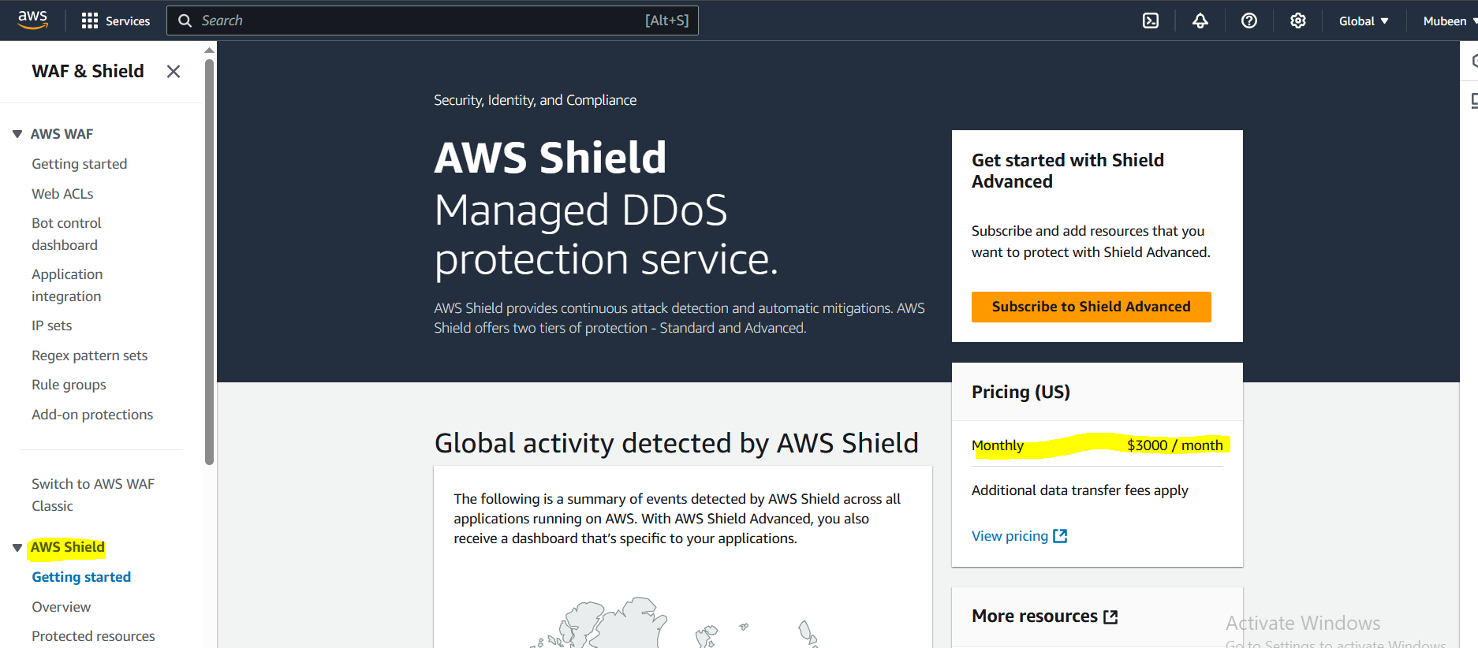

It is used to protect DDOS, DDOS means our server having 10 Requests Capacity but any Hacker is sending 1000+ requests to our server which may result in crashing our server.

AWS Systems Manager

1. What is AWS Systems Manager?
A service to manage, automate, and monitor your AWS resources and on-premises servers in one place.

2. Why Use Systems Manager?
To simplify resource management, automate operational tasks, and improve security and compliance.

3. Where is Systems Manager Used?
Used to manage EC2 instances, servers, databases, and other AWS resources across multiple environments.

4. How Does It Work?
Provides a unified interface and automation tools to view, control, and configure resources at scale.

5. Key Features
- Run Command: Execute commands remotely on instances.
- Patch Manager: Automate OS patching.
- Parameter Store: Securely store configuration data and secrets.
- Automation: Automate workflows.
- Inventory: Collect metadata about your resources.

6. Security
Integrates with IAM for access control and uses encryption for storing sensitive data.

7. Costing
Many features are free; some advanced automation workflows and compliance scanning may have additional charges.

8. Integration
Works with EC2, on-prem servers, Lambda, CloudWatch, CloudTrail, and more.

9. Monitoring and Compliance
Helps monitor instance health, patch compliance, and config drift to maintain security standards.

10. Best Practices
Use Parameter Store for configs, automate patching, use Run Command for safe remote access, and enable logging.

Task on AWS Systems Manager (Session Manager)
We are Launching 2 instances to execute this task.
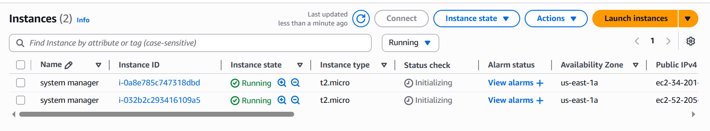
Creating a IAM role to connect EC2 with system manager(SSM).
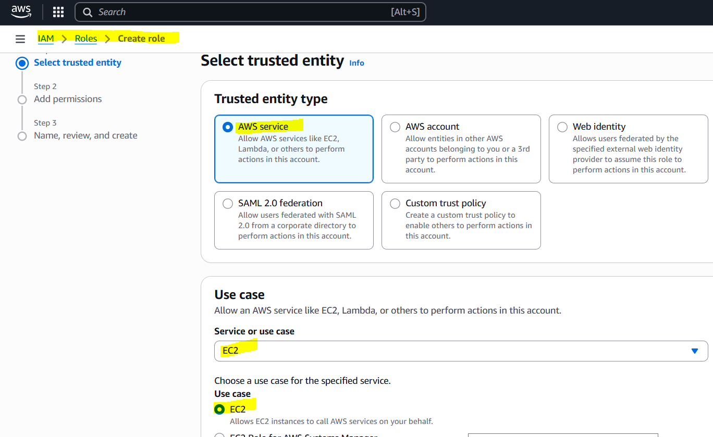
To Enable multiple actions selecting Full access.
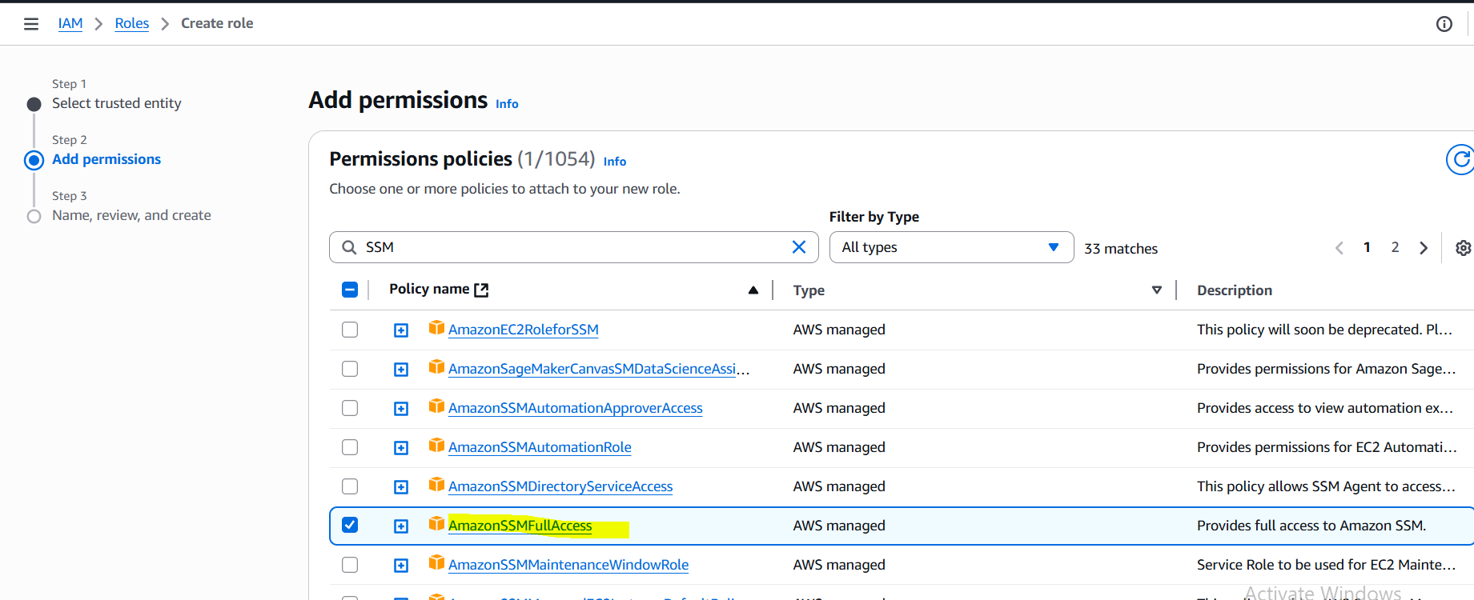
After that Name the role, review the role and click on Create role.
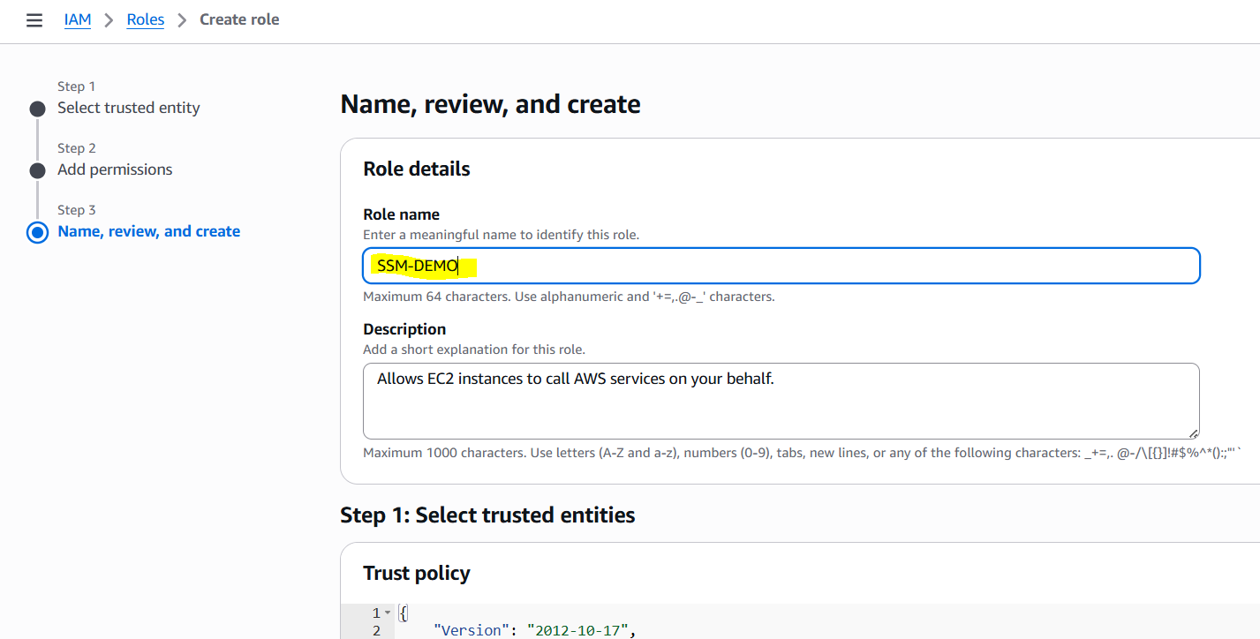

Attach this role to Our launched Instances.
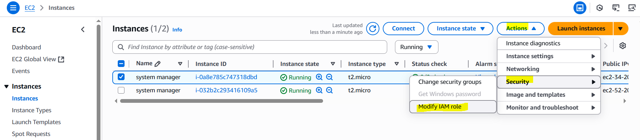

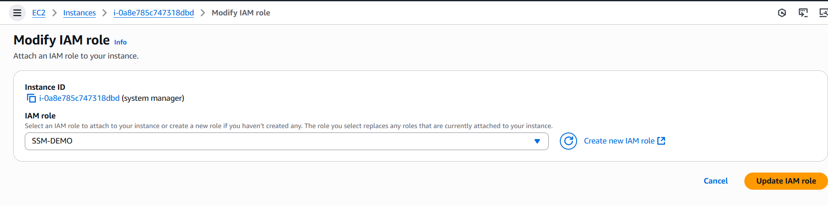
Similarly adding role for both the instances.
We can see that instances are added.
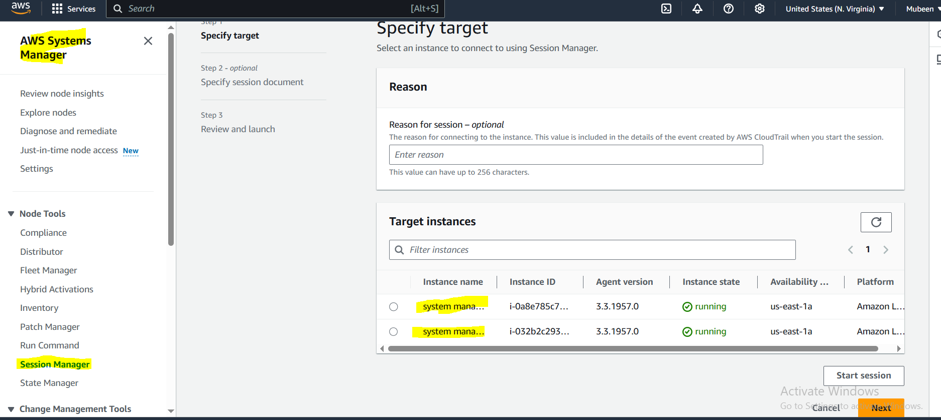
Now we can have access to instance by clicking on Start session after selecting the required instance.
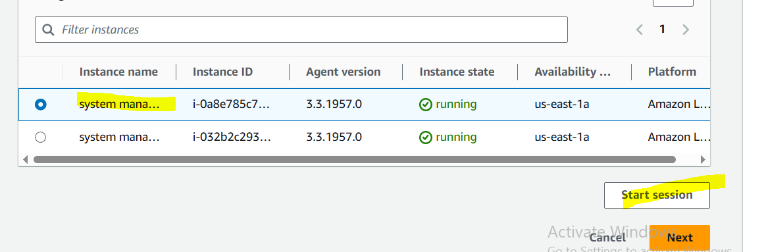

This is the session.
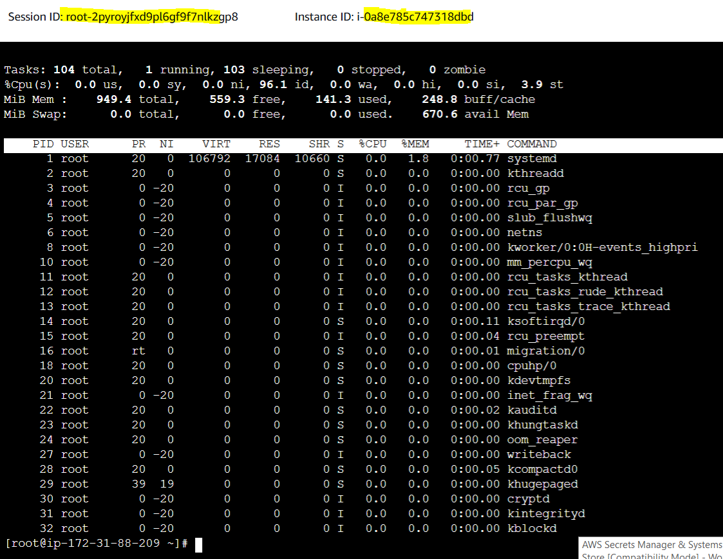
We can terminate it from here.
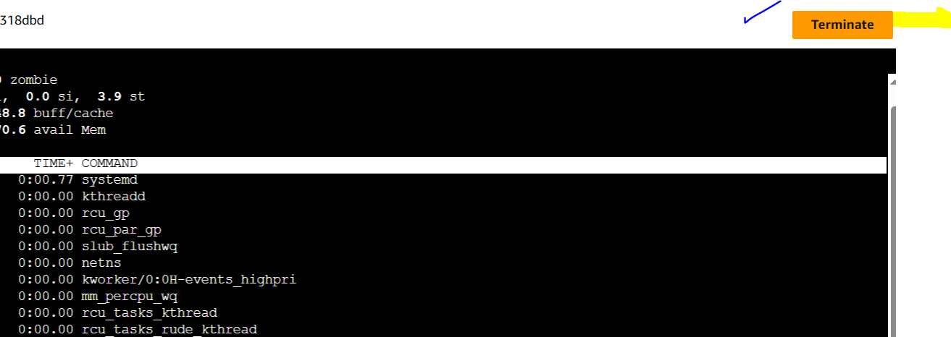

This option will also be Enabled. We can connect to Small Sessions through here.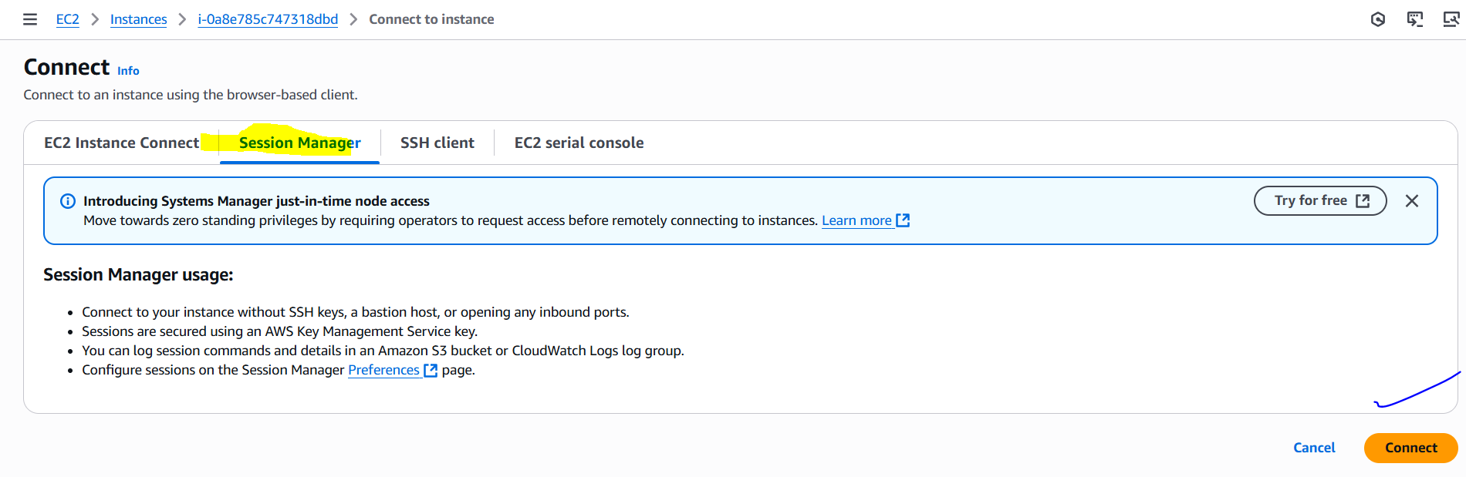
Parameter store:
Go to the System Manager select parameters and click on create Parameters.
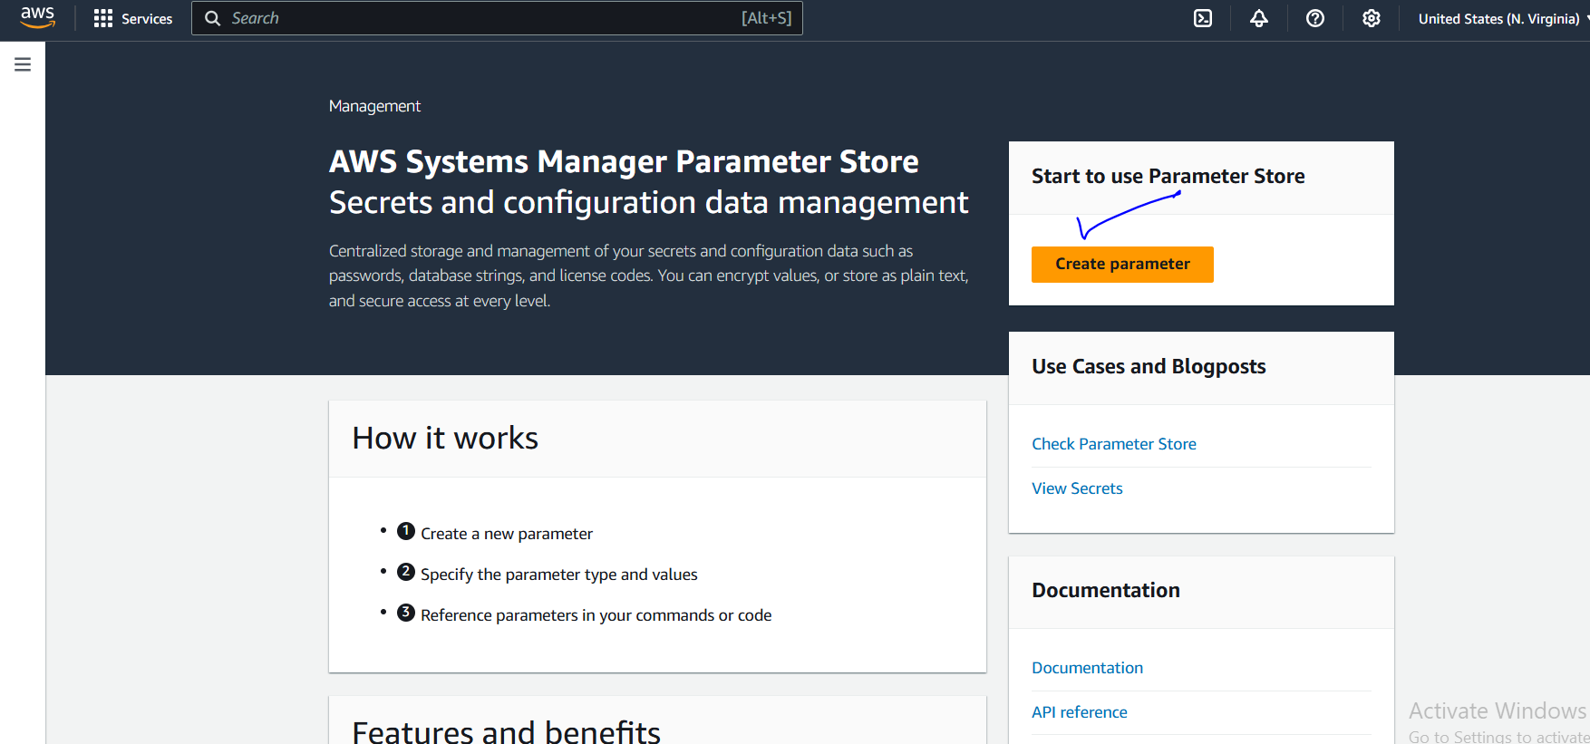

Give it a name and select tier Standard. Used to store Database URL.
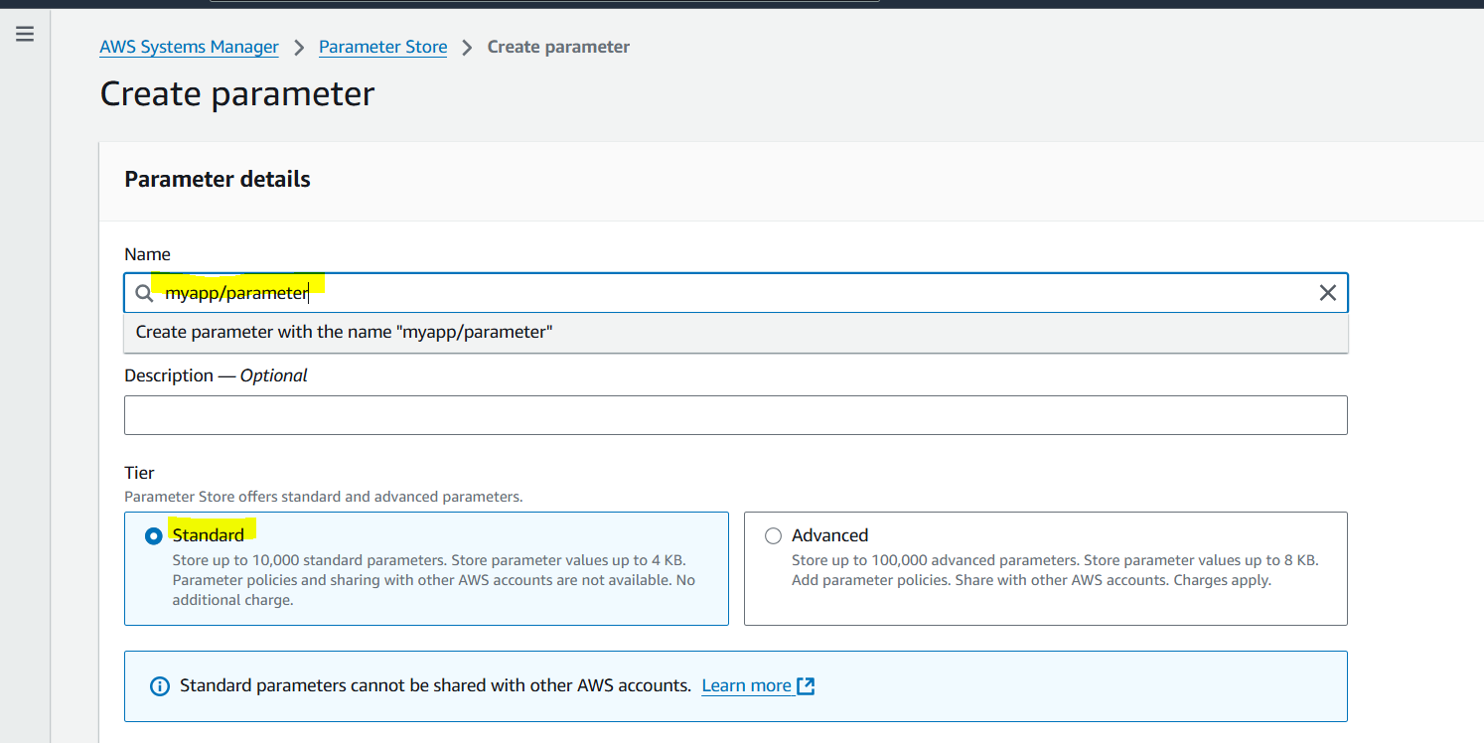
Select the string, data type as text and add Required Value then click on Create Parameter.
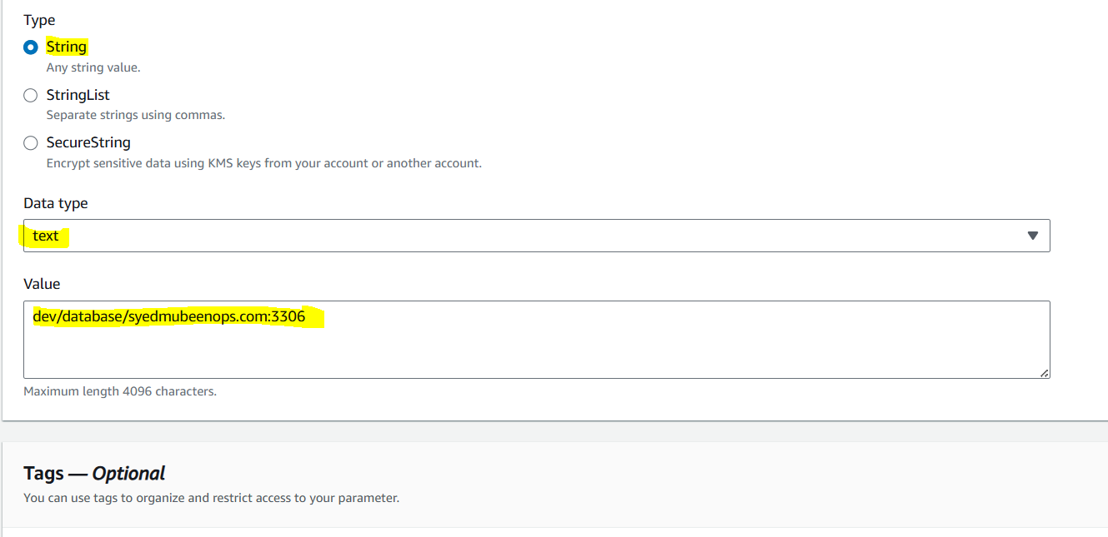
It is created.
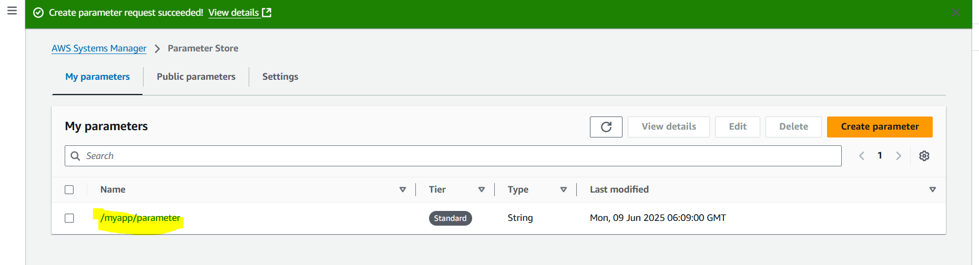
Creating one more parameter to store user name.
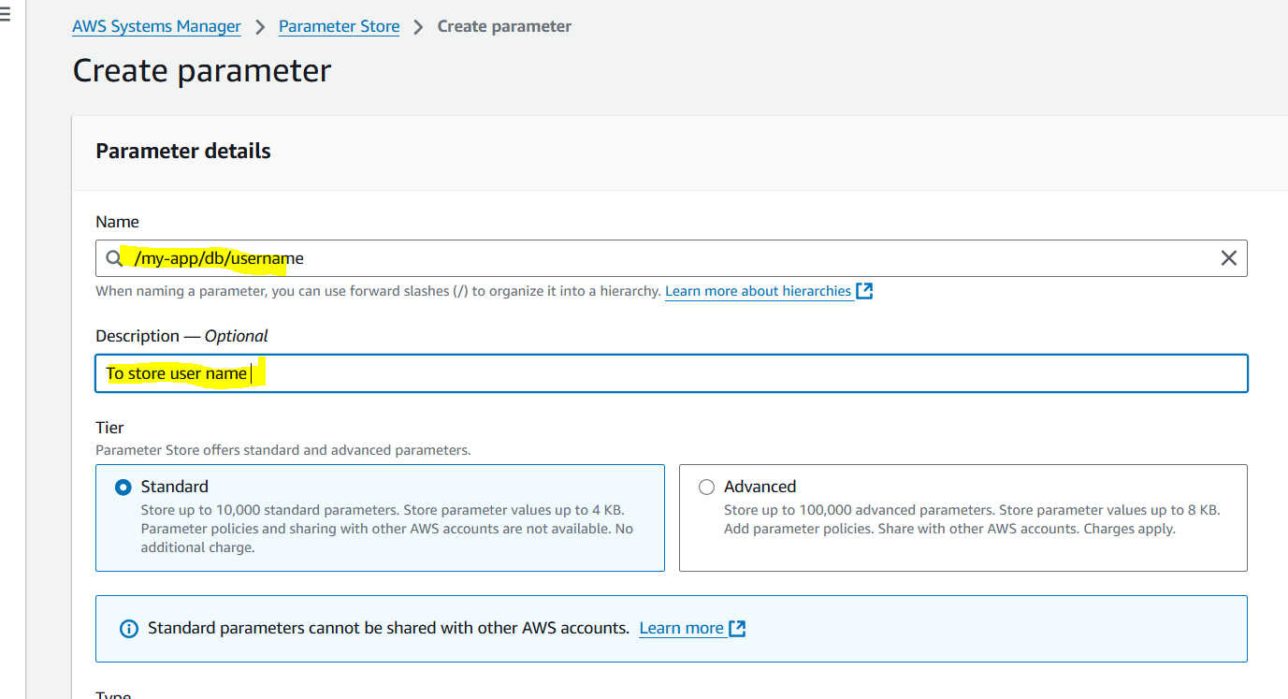
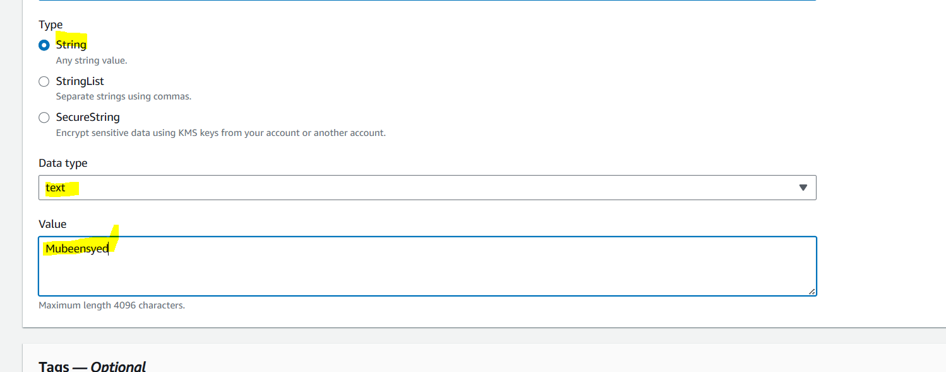
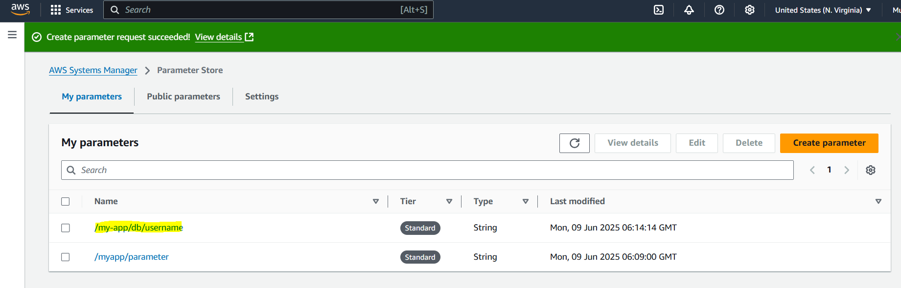
We can also add Passwords and use KMS for encryption.
THE-END

